APC INDEX
The following is a list of APC bulletins from 2014 through to 2019 with a limited number of articles available to display. You can download a copy of all articles from APC Volume 13 Issue 1 to the present from Informit at a cost of $33.00 per article.
Australasian Plant Conservation Volume 25 Number 4 March 2017 – May 2017  Printed in full colour  New approaches to fighting native plant extinction – Gregory Andrews  Restore & Renew, a wealth of new information in support of ecological restoration practices – Maurizio Rossetto  Climate-ready revegetation. A guide for natural resource managers – Nola Hancock, Rebecca Harris, Linda Broadhurst and Lesley Hughes  Genetic rescue of the Plains Yam Daisy (Microseris scapigera) on the Merri Creek – Brian Bainbridge  Managing imperfection in post-mined landscapes: determining the best practicable ecosystem reference sites – Nic McCaffrey, Peter Erskine and David Doley  The devolved grant model: Achieving lasting conservation outcomes across Tasmania – Peter Stronach  Engineered co-existence of novel green roof habitat holds conservation promise – Pamela J.A. Spencer  Friends of the Royal Tasmanian Botanic Gardens Grant Recipient Report 2016 – Attending the 11th Australasian Plant Conservation Conference (APCC11) – Lorraine Perrins  Report on APCC11 Conference Field Trip to Wilsons Promontory National Park – Geoff Robertson  Regular features  News from the Australian Seedbank Partnership  ANPC Member Profile  News  Workshop Report  Research Roundup  ANPC Corporate Members  Australasian Plant Conservation Volume 25 Number 3 December 2016 – February 2017  Printed in full colour  From the editor – Paul Adam  President’s Report – Linda Broadhurst  The threat of myrtle rust to the conservation of the endangered tree, Gossia gonoclada (Myrtaceae) in south east  Queensland – Tamara Taylor, Louise Morin, Geoff Pegg and Jacinta Zalucki  Holding on to Tea-tree fingers: a critically endangered fungus –Tom W. May and Sapphire J.M. McMullan-Fisher  Fontainea dude thinks he’s a lady – recovery of the Coastal Fontainea and investigation into temporal monoecy – Dianne Brown, Rhonda James and Annette McKinley  Threatened species management on the rural-urban interface: insight from a critically endangered shrub – John Patykowski, Matt Dell and Maria Gibson  Parks and people: Promoting plant conservation – Anne Cochrane  New approaches to plant conservation challenges. Conservation for people and nature, benefiting both. Reflecting on FOG’s experience, learning and vision – Geoff Robertson  Effect of fire and digestion by herbivores on seeds of the exotic invasive species Acacia nilotica in savanna at Baluran National Park Indonesia – Sutomo and Eddie van Etten  Regular features  News from the Australian Seedbank Partnership  ANPC Member Profile  News  Book Reviews  Workshop Report  Research Roundup  ANPC Corporate Members  Australasian Plant Conservation Volume 25 Number 2 September – November 2016  Printed in full colour  From the editor - Paul Adam  How do germination responses to smoke relate to phylogeny, growth form, fire response strategies and vegetation type? A focus on eastern Australia - Alexandra J.R. Carthey and Michelle R. Leishman  How fire and seasonal temperatures influence the germination of many plant species: insights from Boronia (Rutaceae)- Berin D.E. Mackenzie,Tony D. Auld, David A. Keith and Mark K. J. Ooi  Changes in seed dormancy over time in fire‑prone flora - Ganesha Liyanage and Mark Ooi  The rainforest challenge – testing the ‘unstorable seed’ assumption - Karen D. Sommerville, Graeme Errington, Zoe-Joy Newby and  Catherine A. Offord  Seeds of change: A case study in improving rehabilitation success – Alice Quarmby  A non-seed based method for enhancement planting of the critically endangered Pomaderris delicate - Joe McAuliffe, David Taylor and  Keith McDougall  Counting the uncountable: estimating abundance of the rhizomatous Stackhousia subterranean W.R.Barker (Celastraceae) - Mark Wapstra and Lorilee V. Yates  Regular features  News from the Australian Seedbank Partnership  ANPC Member Profile  News  Book Reviews  Workshop Report  Research Roundup  ANPC Corporate Members | 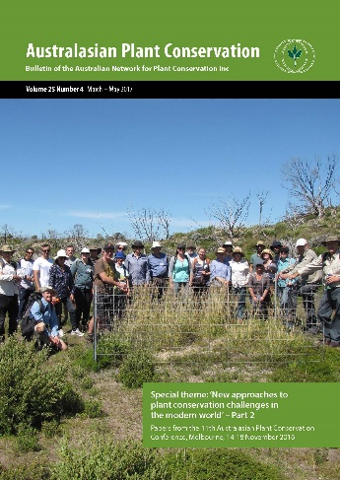  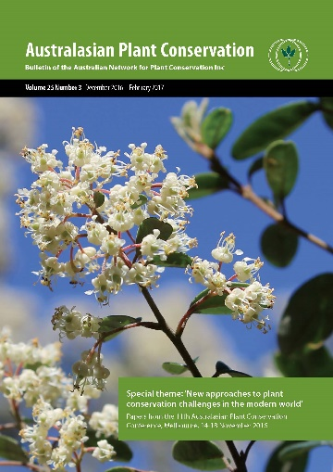  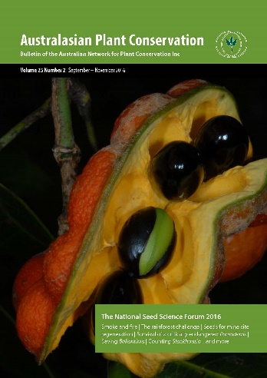

Australasian Plant Conservation Volume 25 Number 1 June – August 2016  Printed in full colour  From the editor - Paul Adam and Zoe Knapp  KeyBase – teaching old keys new tricks - Kevin Thiele and Niels Klazenga  An eFlora of Australasia: a collaborative and dynamic online platform for managing Floras - Zoe Knapp, Kevin Thiele, Rebecca Pirzl and Michael Hope  FunKey or not so fun: creating interactive keys to macrofungi - Tom May  Australian Tropical Rainforest Plants Identification System - Frank Zich and Raelee Kerrigan  How do you identify your plant? - Louisa Murray, Barbara Wiecek and Joel Cohen  The Key to Tasmanian Vascular Plants - Greg Jordan  Considerations for large-scale biodiversity reforestation plantings. Part 8: project monitoring and evaluation - Dan Cole and Greg Siepen  Images worth a thousand ideas: Digitising the National Seed Bank collection - Brook Clinton and Lydia Guja  Regular features  News from the Australian Seedbank Partnership  ANPC Member Profile  News  Book Reviews  Workshop Report  Research Roundup  ANPC Corporate Members | 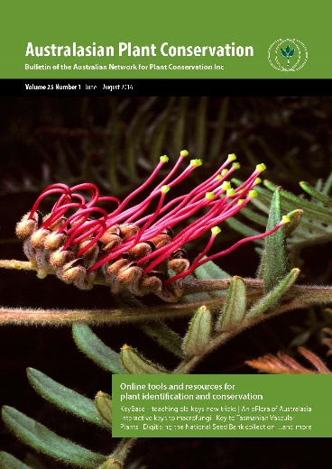

Australasian Plant Conservation Volume 24 Number 4 March – May 2016  Printed in full colour  From the editor - Paul Adam  Vale Roger Good  Towards a centre for intergrated adaption research in the Australian mountains - Adrienne B. Nicotra, Justin Borevitz,  Michael Dunlop, Ary Hoffmann, Jamie Kirkpatrick, Angela Moles, John Morgan, Albert van Dijk and Roger Good  Tribute from the Australian National Botanic Gardens to Roger Good - Sabrina Sonntag  Roger Good and the bogs and fens of the Australian Alps - Jennie Whinam and Genevieve Wright  Roger Good’s role in developing restoration techniques in temperate highland peat swamp on sandstone in the Blue Mountains -  Shane Grundy  The impacts of increasing solar ultraviolet light on the wetland mires of the mainland Australian Alps - Roger Good, Genevieve Wright,  Geoff Hope and Jennie Whinam  Explaining feedbacks between fire and flammability in the Snowgums and beyond - Philip Zylstra  The vulnerability of peatlands in the Australian Alps - Ben J. French, Geoffrey S.Hope, Lynda D. Pryor and David M.J.S. Bowman  The unique and surprising environments of Temperate Highland Peat Swamps on Sandstone (THPSS) in the Blue Mountains, NSW -  Scott Mooney and Len Martin  The benefits of restored linear vegetation corridors for biodiversity conservation – a case study - Stuart Johnston and Roger Good  Management of herbivory in the Montane Heath and Thicket TEC of the eastern Stirling Range, Western Australia - Sarah Barrett  and Damien Rathbone  Can synthetic vegetation (novel ecosystems) help nature conservation in the Anthropocene? - Peter Bridgewater  Regular features  News from the Australian Seedbank Partnership  ANPC Member Profile  News  Book Reviews  Workshop Report  Research Roundup  ANPC Corporate Members | 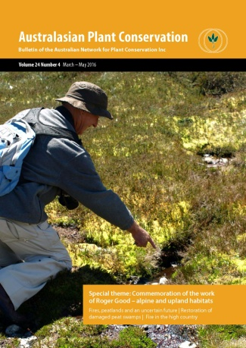
Australasian Plant Conservation Volume 24 Number 3 December 2015 – February 2016  First edition printed in full colour  From the editor - Paul Adam  President’s Report - David Coates  Introduction to new ANPC President  The enigmatic Myxomycetes - Sarah Lloyd  Conservation of fungi in Lane Cove Bushland Park - Ray and Elma Kearney  Waxcap conservation in England and Wales and a new approach to translocation - Barry Wright  Endless forms most bizarre - Alison Pouliot  Biological soil crust morphogroups: function follows form - Max Mallen-Cooper  Extensive and diverse biocrusts protect remnant dunes and flood plains of Bladensburg National Park - Wendy Williams, Burkhard Büdel, and Colin Driscoll  Considerations for large-scale biodiversity reforestation plantings. Part 6: landholder and community engagement - Dan Cole  and Greg Siepen  Considerations for large-scale biodiversity reforestation plantings. Part 7: risk management and contingency planning - Dan Cole  and Greg Siepen  Regular features  News from the Australian Seed Bank Partnership  ANPC Member Profile  Book reviews  News  Workshop report  Research Roundup  ANPC Corporate Members | 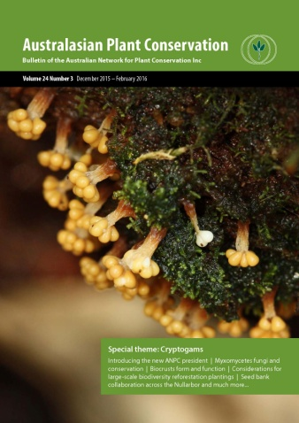
Australasian Plant Conservation Volume 24 Number 2 September – November 2015  From the editor - Paul Adam  Saving arid and semi-arid southern Australia after over 150 years of exotic grazing pressure: have we got the time and the will? -  Tony D Auld, Andrew Denham, Mark Tozer, John Porter, Berin Mackenzie and David Keith  The gritty fight against feral rabbits: testing the effectiveness of a browsing deterrent (Sen‑TreeTM) on native grassy‑groundcovers -  Chris Macris, James Mcnamarra and Evan FreameThe use of aerial survey to support rabbit control and native vegetation regeneration on the Hay Plains of NSW - Suzanne Holbery, Michael Leane and Ray Willis Australian National Botanic Gardens – Master Plan  Rangeland vegetation recovery with feral goat control - Renée-Claire Hartley  Reflecting on Feral Status - Paul Gibson-Roy  Considerations for large-scale biodiversity reforestation plantings. Part 5: project management - Dan Cole and Greg Siepen  The shock of the new? - Paul Adam  Introducing the Australian Seed Bank Partnership - Anne Cochrane  Regular features  ANPC Member Profile  Workshops  News  Research Roundup | 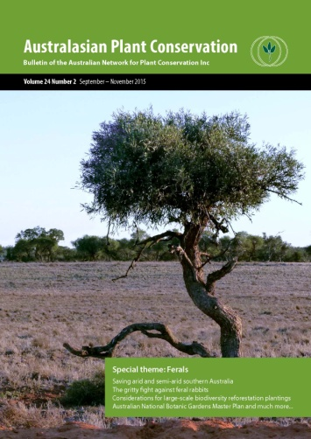
Australasian Plant Conservation Volume 24 Number 1 June – August 2015  From the editor - Huw Morgan  Citizen science: Community monitoring of Marri canker disease - Alex Chapman, Cielito Marbus, Trudy Paap, Treena Burgess  and Giles Hardy  Unravelling the secrets of the Crowded Leek Orchid: a partnership between volunteers and business - Philip Collier and James Dick  When is a Yam Daisy more than a Yam Daisy? When is a grassland more than a grassland - Paul Gibson-Roy  Democratisation of biological collections: developing an online image herbarium for mine rehabilitation sites in Queensland - Nic McCaffrey, Andrew Fletcher, Peter Erskine, David Mulligan and Michael Giddens  Murrumbidgee Bossiaea – a Canberra collaboration - Alison McInnes, Tom North, Lydia Guja, Luke Johnston and Julian Seddon  Seedballs: a useful tool for revegetating difficult terrain? - Ian Rayner, Sarah Hnatiuk and Graham Fifield  Vegwatch: a citizen science program for monitoring vegetation condition - Sarah Sharp, Linda Beveridge, Melinda Hillery, Jo Lynch  Citizen science and conservation: Are volunteers the way of the future for effective decision-making? - Ayesha Tulloch  Considerations for large-scale biodiversity reforestation plantings. Part 4: maintenance - Dan Cole and Greg Siepen  Regular features  ANPC member profile  Book review  News  Workshop report  Research roundup | 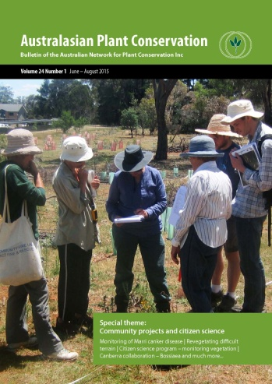
Australasian Plant Conservation Volume 23 Number 4 March – May 2015  From the editor - Huw Morgan  Wildfire reveals new populations of the endangered Commersonia rosea and Monotaxis macrophylla in northern Wollemi National Park, NSW - Stephen Bell and Bill Holzinger  Translocating the Spiny Daisy: partnerships with winning outcomes - Doug Bickerton and Christophe Tourenq  Using seed production areas to meet restoration targets and secure genetic diversity - Linda Broadhurst, Tara Hopley, Lan Li, Jim Begley  The Jaliigirr Biodiversity Alliance – connectivity is key - Dianne Brown  The New Zealand Plant Conservation Network - Rewi Elliot  In defence of ferals and weeds by Paul Gibson-Roy  Towards new nursery industry protocols for Phytophthora control: supply of stock for restoration and revegetation by David J. Hancock  Phenology and its contribution to understanding how plants adapt to a changing world - Marie R. Keatley  Plenary Lecture: Engagement and Communication in the Modern World subtheme  Communicating, connecting, inspiring, acting in the modern world - Andrew Smith  Sacred values and filthy lucre – taboo trade‑offs in conservation. A perspective on the triage debate - Terry Walshe, Rodrigo Estevez, Zoe Knapp and Martina Di Fonzo  Considerations for large-scale biodiversity reforestation plantings. Part 3: implementation phase - Dan Cole and Greg Siepen  Regular features  ANPC member profile  Projects in focus  Book reviews  Research Roundup  ANPC Corporate Members | 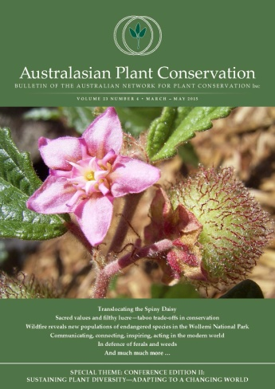
Australasian Plant Conservation Volume 23 Number 3 December 2014 – February 2015  From the editor - Huw Morgan  President’s Report - David Coates  Opening address to the 10th Australasian Plant Conservation Conference 2014 - David Coates  Keynote Address: Communicating science. Does social media carve a gap between young and old readers? - Ian Lunt  Plenary Lecture: Animals in Plant Conservation subtheme  Plant and animal conservation: you can’t have one without the other! - Jonathan Majer  Feral deer damage in Tasmanian restoration plantings - Tanya G Bailey, Archana Gauli, Paul Tilyard, Neil J Davidson, Brad M Potts  Understanding plant responses to changing climates: seed germination, seedling emergence and early growth in Banksia - Anne Cochrane, Gemma L. Hoyle, Colin J. Yates and Adrienne B. Nicotra  Teaming with volunteers to save our rare flora - Bob Dixon  Alpine restoration: identifying needs and determining priorities - Roger Good, Stuart Johnston, Adrienne Nicotra and Jennie Whinam  Assessing the risk of gene flow from plantation to native eucalypts: A long-term partnership in biodiversity management -  Matthew J Larcombe, Tim Leaman, René E Vaillancourt and Brad M Potts  Gardens for Wildlife: promoting biodiversity conservation in urban areas - Iona Mitchell  What’s killing the trees? Is climate change the cause of Ribbon Gum (Eucalyptus viminalis) dieback in the Monaro region of NSW? - Catherine Ross  Azorella macqauriensis: battling for survival in the subantarctic - Natalie Tapson  Moving from monoculture to multiculture: a history of Bitou Bush on the Tweed Coast, northern NSW - Rhonda James, Tanya Fountain  and John Turnbull  Considerations for large-scale biodiversity reforestation plantings. Part 2: the planning framework - Dan Cole and Greg Siepen  Regular features  ANPC member profile  Book review  Information resources and useful websites  Research roundup  ANPC Corporate Members | 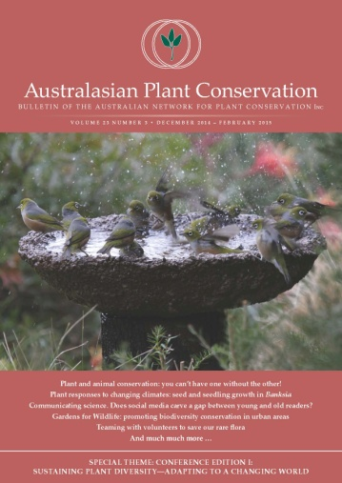
Australasian Plant Conservation Volume 23 Number 2 September – November 2014  From the editor - Huw Morgan  Biosecurity in Australia: a snapshot of biosecurity policy and initiatives at the Australian Government Department of Agriculture -Sustainability and Biosecurity Policy Division  Victoria’s Hawkweed eradication program: an enduring Alpine partnership - Cindy Hauser, Neil Smith and Charlie Pascoe  Managing invasive plant species using spatially explicit population modelling - Nicholas Beeton  Wild Native Rose: untangling the causes of population decline - Kate Brown and Cathy Bourke  Volunteers tackle native woody weeds jumping the Garden’s fence - Rosemary Purdie  When biosecurity is threatened from within: the case of the native environmental weed, Pittosporum undulatum - Dr Steven Douglas  Dr Jekyll and Mr Hyde: recently introduced pests of invasive flora may also threaten endangered native species - Peter Ridgeway  and Alex Burgess-Buxton  Considerations for large-scale biodiversity reforestation plantings. Part 1: securing access to land - Dan Cole and Greg Siepen.  Regular features  ANPC member profile  Report from New Zealand Plant Conservation Network  Conference report  Upcoming conferences and workshops  Information resources and useful websites  Research round up  ANPC Corporate Members | 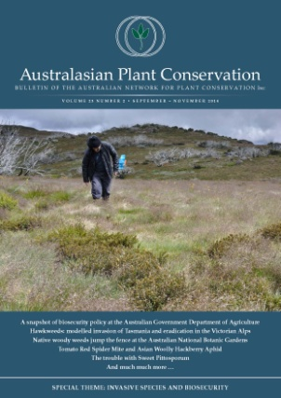
Australasian Plant Conservation Volume 23 Number 1 June - August 2014  From the editor - Huw Morgan  Canberra Nature Map: an online community discovering and recording Canberra’s floral treasures - Aaron Clausen  Ants, Seeds and Grassland Restoration - Paul Gibson-Roy  Linking Schools to Biodiversity Restoration: The Willmot Public School Connecting the Cumberland Program - Paul Gibson-Roy  and Anne Denham  Suggested strategies for germinating recalcitrant seeds - David Hancock  Myrtle Rust – what’s happening? - Bob Makinson  Regular features  ANPC member profiles  Workshop report  Upcoming conferences and workshops  Information resources and useful websites  Research round up  ANPC Corporate Members | 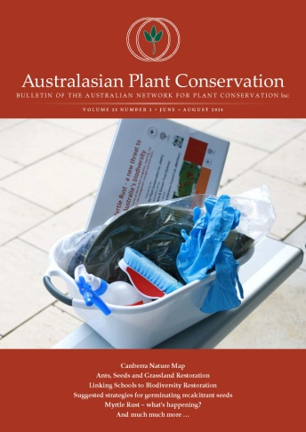
Australasian Plant Conservation Volume 22 Number 4 March – May 2014  From the editor - Huw Morgan  Introduction to the Global Strategy for Plant Conservation - Suzanne Sharrock  Global Strategy for Plant Conservation: Australia’s National Focal Point - Judy West and Zoë Knapp  The Australian Seed Bank Partnership’s contributions to the Global Strategy for Plant Conservation - Dr Lucy A. Sutherland  Seed longevity of Australian species - David Merritt  What are we conserving? Living collections contributing to Target 8 of the Global Strategy for Plant Conservation - Zoë Knapp,  Lottie Boardman, Belinda Brown and Judy West  Addressing Target 8 of the Global Strategy for Plant Conservation in Western Australia - Anne Cochrane, Andrew Crawford  and David Coates  Global Strategy for Plant Conservation and the National Arboretum Canberra - Mark Richardson, Adam Burgess, and Lynne Sealie  Working towards securing plant biodiversity in Tasmania - Lorraine Perrins and James Wood  Conservation on a remote island: safeguarding the Macquarie Island Cushion Plant (Azorella macquariensis) - Lorraine Perrins  and Natalie Tapson  It’s time for a Global Strategy for Plant and Fungus Conservation - Alison Pouliot, Tom May, Sapphire McMullan-Fisher, Peter Buchanan, Lyn Allison and Jasmin Packer  Regular features  ANPC Member profile  Projects in focus  Upcoming conferences and workshops  Website review  Information resources and useful websites  Research round up | 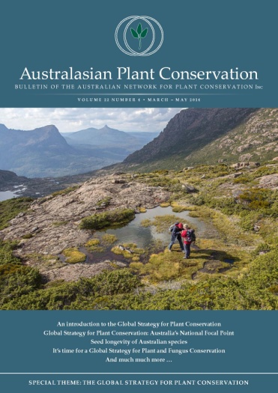
Australasian Plant Conservation Volume 22 Number 3 December 2013 – February 2014  From the editor - Selga Harrington  President’s Report - David Coates  Are seed banks misunderstood? A perspective from the Millennium Seed Bank - Paul Smith  Historic seed collections germinated for the Australian PlantBank opening - Monica Fahey, Amelia Martyn  and Cathy Offord  Meeting the seed needs for future restoration - Paul Gibson-Roy and John Delpratt  Seed production project produces translocation spin off for a highly threatened species - David Taylor, Joe McAuliffe, Tom North, Paul Gibson-Roy, Bindi Vanzella, Nicki Taws, Greg Baines, Emma Cook, Brendan Lepschi and Linda Broadhurst  Germination of the endangered species Port Lincoln Speedwell in response to season and fire cues - Jenny Guerin, Michael Thorpe,  Dan Duval and Phillip Ainsley  A comparison of germination stimulants applied to five difficult to germinate native species from Queensland -Tima Racule  and Philip M. Cameron  Brief notes on Baeckea kandos, a highly restricted endemic from Wollemi National Park - Steve Clarke  Regular features  ANPC Member profile  Recent workshop reports  Upcoming conferences and workshops  Book review  Information resources and useful websites  Research round up | 