11th Australasian Plant Conservation Conference

“New Approaches to Plant Conservation Challenges in the Modern World”
14 - 18 November 2016, Melbourne, Victoria

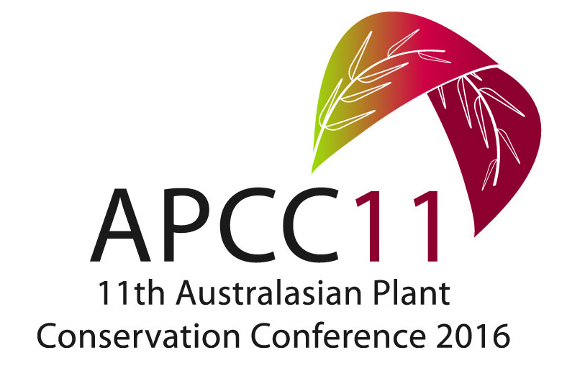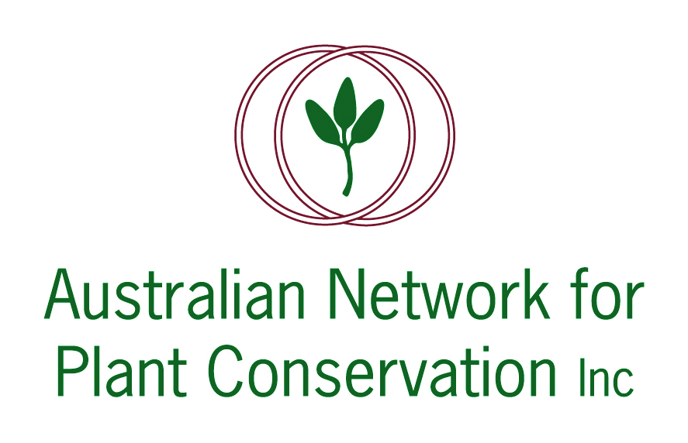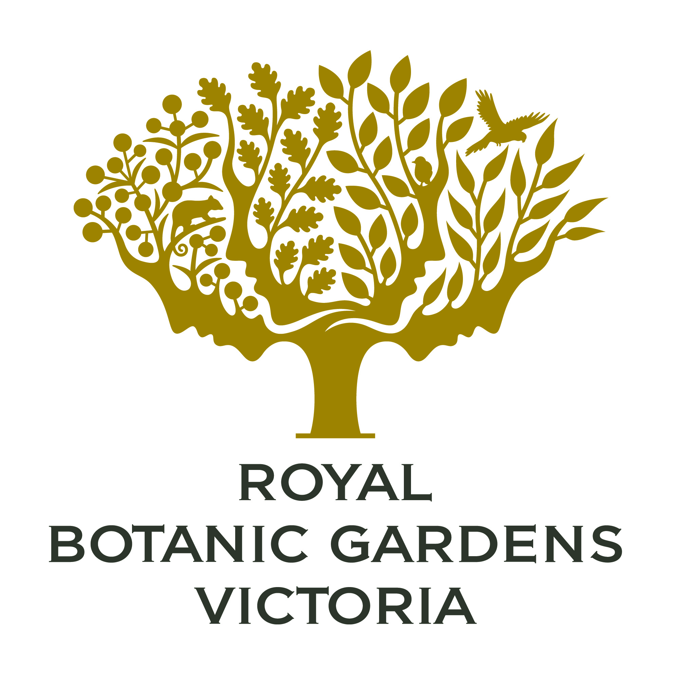

ABSTRACT: PLENARY LECTURE 3

‘How do people think about plants, and why is this important for plant conservation?’

Dr David Kendal
School of Ecosystem and Forest Sciences, University of Melbourne VIC, 3010

We are becoming increasingly interested in the social dimensions of conservation: what shapes the way people think about plants, and how does this thinking influence conservation outcomes? We (and others) have been exploring people’s values, beliefs and attitudes to nature, and their response to the management of vegetation. This work shows that society’s values have changed over the last 50 years – we have shifted from a utilitarian to a mutualistic relationship with nature, and people have strong values for nature, both inside and outside cities. At the same time, the community is diverse and different people have diverse opinions. Geography is not a very good predictor of the way people think – but their interests are. This means that the general public often thinks differently than special interest groups, or experts. The good news is that people are often more supportive of conservation than we assume.

