11th Australasian Plant Conservation Conference

“New Approaches to Plant Conservation Challenges in the Modern World”
14 - 18 November 2016, Melbourne, Victoria

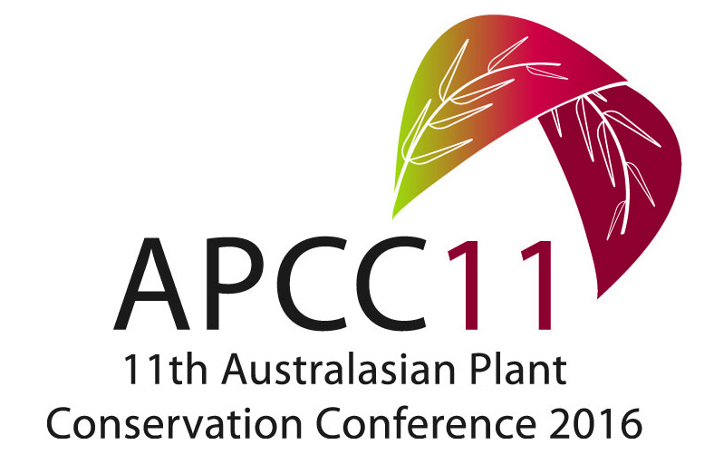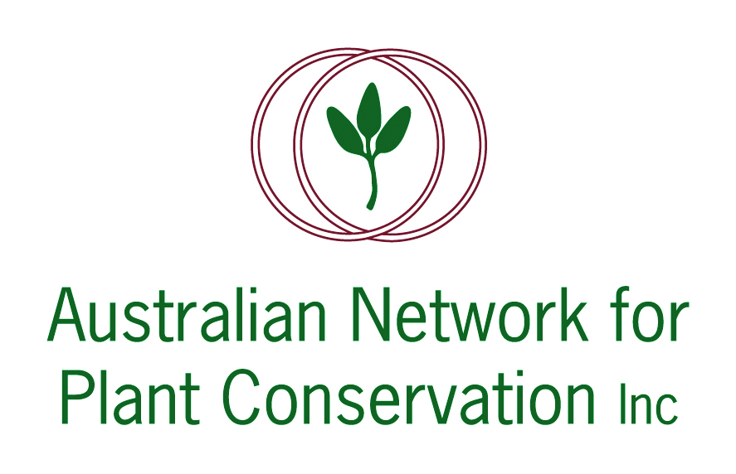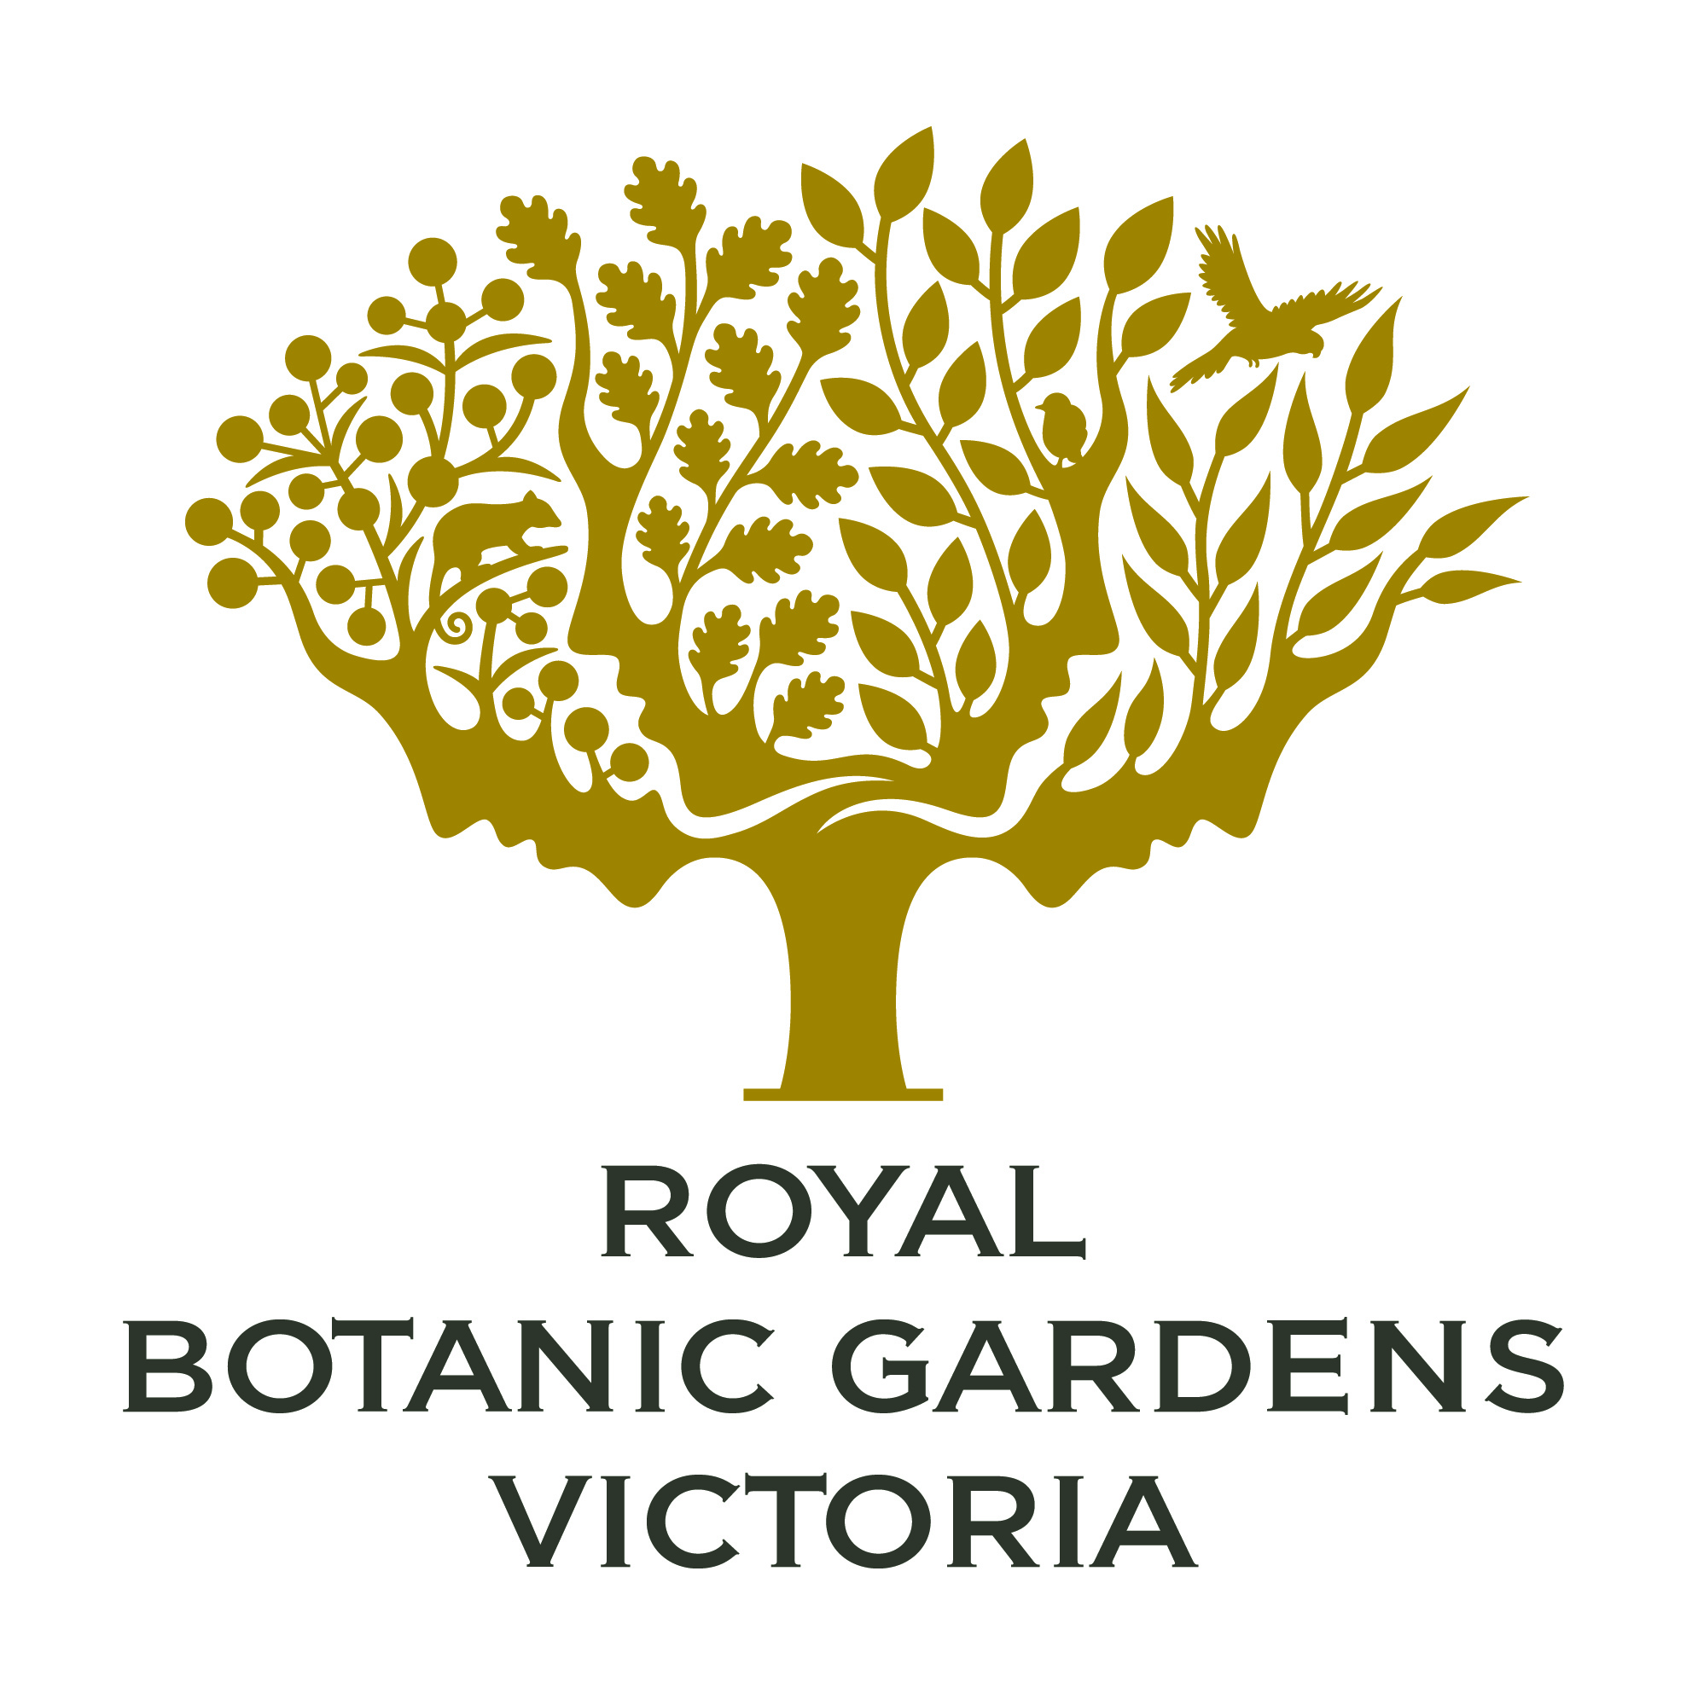

ABSTRACT: PLENARY LECTURE 1

‘Lost in the desert or Red Hot? A botanical tour around Australia, beginning on the Paroo River’

Dr Jen Silcock
Threatened Species Recovery Hub, National Environmental Science Program (NESP),
University of Queensland, St Lucia, 4072
Queensland Herbarium, Department of Science, Information Technology and Innovation (DSITI),
Brisbane Botanic Gardens, Mt Coot-tha Road, Toowong, 4066

My odyssey began on the Paroo floodplain near Hungerford in the spring of 2006, with the discovery of a small but distinctive burr (Sclerolaena walkeri) unseen for 50 years now flourishing in the land described by Henry Lawson as a ‘blasted barren wilderness’. How could this plant, which I found in abundance across south-west Queensland’s five major river systems, have gone undetected for decades and be considered Vulnerable to extinction? How many species in this vast, poorly-surveyed land had data on abundance, distribution and basic life history which could reliably inform their conservation status? What role did the archetypal boom and bust cycles of the arid-zone have on rarity and threat? My curiosity piqued, I began a journey by foot, car, pushbike, camel, kayak and helicopter that took me across 635 300 km² of south-western Queensland over 10 years, collecting data to systematically re-asses the conservation status of the flora.

Through examination of Herbarium records and expert interviews, I identified 91 apparently rare and potentially threatened ‘candidate species’ from the 1800 vascular plant species occurring in the region. For each, I recorded my search effort (totalling over 3000 hours) and population data (at 2000 separate populations), which were used to assess species against IUCN criteria. With the exception of 12 artesian spring species, demonstrable threats and/or continuing declines were documented for just six species, while large (>1000 plants), healthy and regenerating populations of 64 of 91 species (70%) were found. The criterion that allows listing of species because of extreme fluctuations (in combination with restricted and fragmented populations) must be carefully interpreted in arid zones, where these fluctuations may be apparent rather than real, and can confer resilience to grazing. This systematic survey approach facilitates robust conservation assessments across vast and poorly known regions, distinguishing species that have merely been lost in space and time from those that are at risk of extinction.

Having spent a decade combing the not-so-dead heart for not-so-rare plants, I’ve now expanded my rare plant searching to cover the continent – although this time, sadly, it’s mostly a desktop search, aimed at compiling a ‘Red Hot’ list of Australia’s most imperilled flora as part of the NESP Threatened Species Recovery Hub. In stark contrast to the inland situation – where only a handful of species are genuinely threatened – many species are both rare and in serious trouble. Around 1100 plant species, about 5% of Australia’s known total, are listed as Endangered or Critically Endangered (under state and/or federal legislation). A fifth of these survive only in a single population, while 60% are known from five or fewer populations. The Red Hot list will (1) identify species that are at most immediate risk of extinction using the best available expert knowledge; (2) identify and prioritise conservation management actions that can significantly reduce the likelihood of extinction for these species; (3) alert relevant stakeholders of this risk and recommended response. To be considered for inclusion, species must be both rare and declining, and have feasible recovery options. This narrowed field will then be assessed against fuzzier criteria such as flagship potential and phylogenetic uniqueness to arrive at the final Red Hot list. Some of the most threatened plants have been translocated, and my second NESP project will collate data about all translocations which have occurred in Australia and analyse their successes, shortcomings and lessons learnt.

It’s been a long and winding trail in search of lost and threatened plants, and it is far from over. Each species holds its own secrets and stories, and provides a window on its habitat and insights into conservation for newcomers in an ancient land.

