11th Australasian Plant Conservation Conference

“New Approaches to Plant Conservation Challenges in the Modern World”
14 - 18 November 2016, Melbourne, Victoria

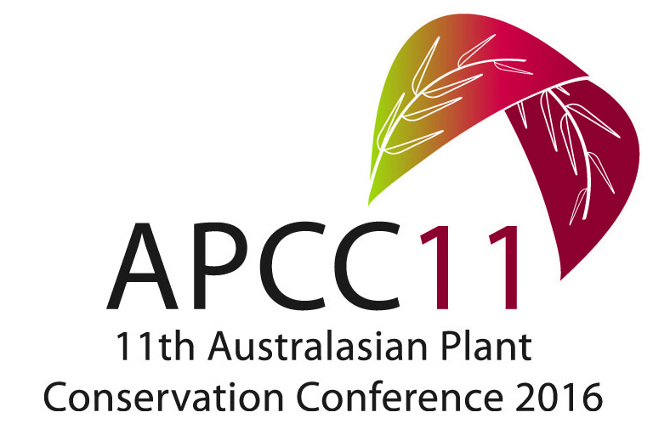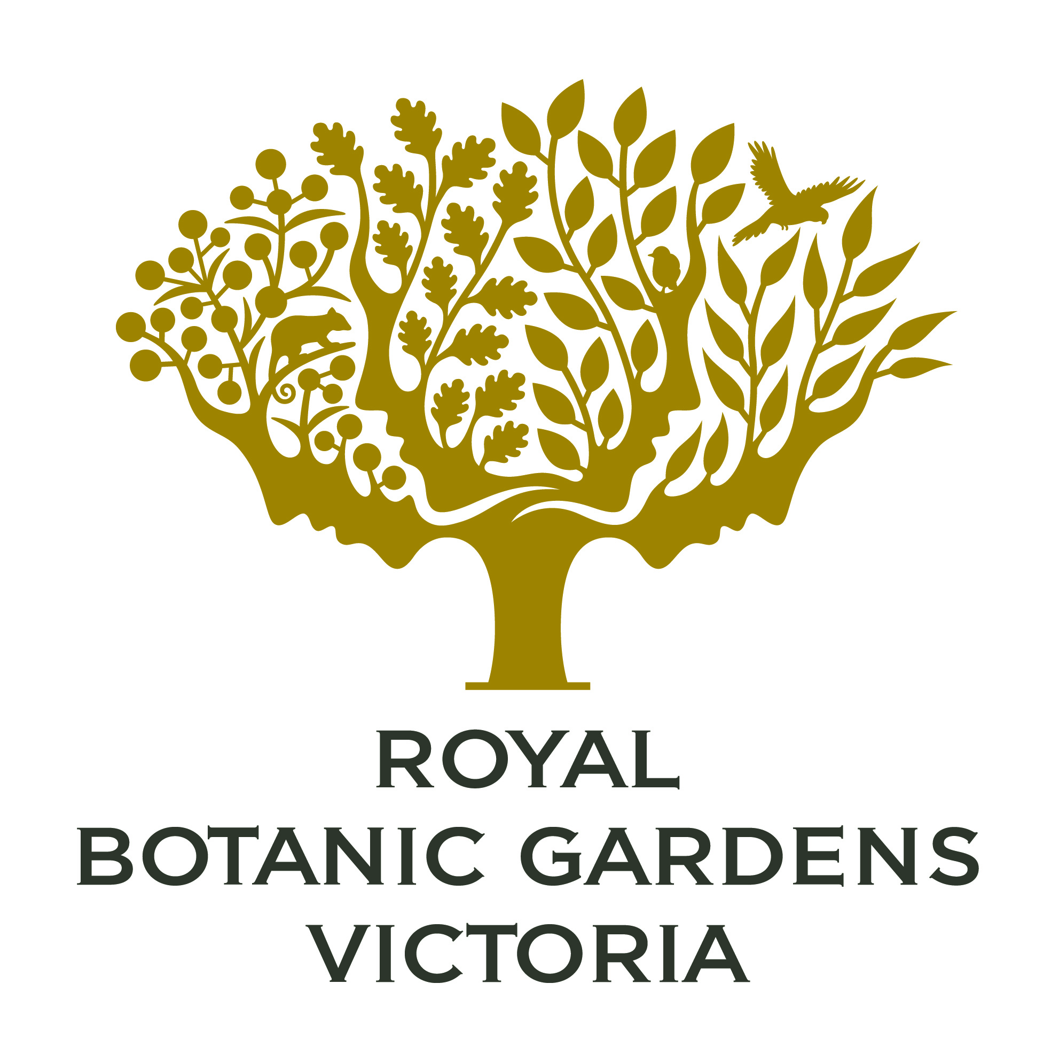

ABSTRACT: PLENARY LECTURE 4

‘Translocation principles and practice: opportunities and challenges for threatened plant recovery’.

Leonie Monks
Department of Parks and Wildlife, Science and Conservation Division
Locked Bag 104, Bentley Delivery Centre, WA 6983

Translocations aim to prevent species extinction by creating or maintaining viable populations and are increasingly being undertaken world-wide in an attempt to stem the tide of biodiversity loss. For a translocation to be effective in helping conserve a population or species, it must be able to successfully establish in the short term and become self-sustaining in the long-term. Challenges for conservation practitioners can include difficulties with propagation, effectively characterising translocations sites to ensure the optimal sites are chosen, improving translocation methodologies to maximise translocation survival and adequately defining and assessing success so it is understood when success is achieved and when resources can be reallocated to other species in need. However, despite the challenges, there are also many opportunities. Where an experimental framework is used we can expand our knowledge on species ecology and conservation, and use this knowledge to continually improve our translocation techniques and increase our chances of success. We can also scale up the knowledge learnt from one or more species to more broad-scale restoration activities. But ultimately the greatest opportunity for conservation practitioners is to significantly reduce the risk of a species going extinct.

