11th Australasian Plant Conservation Conference

“New Approaches to Plant Conservation Challenges in the Modern World”
14 - 18 November 2016, Melbourne, Victoria

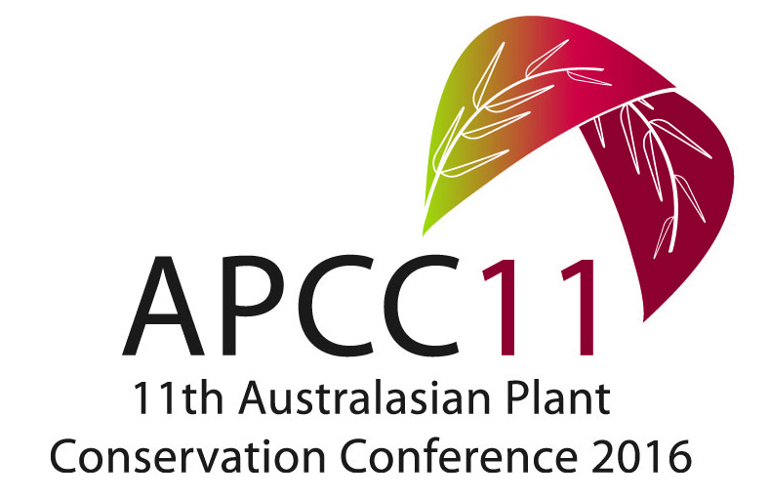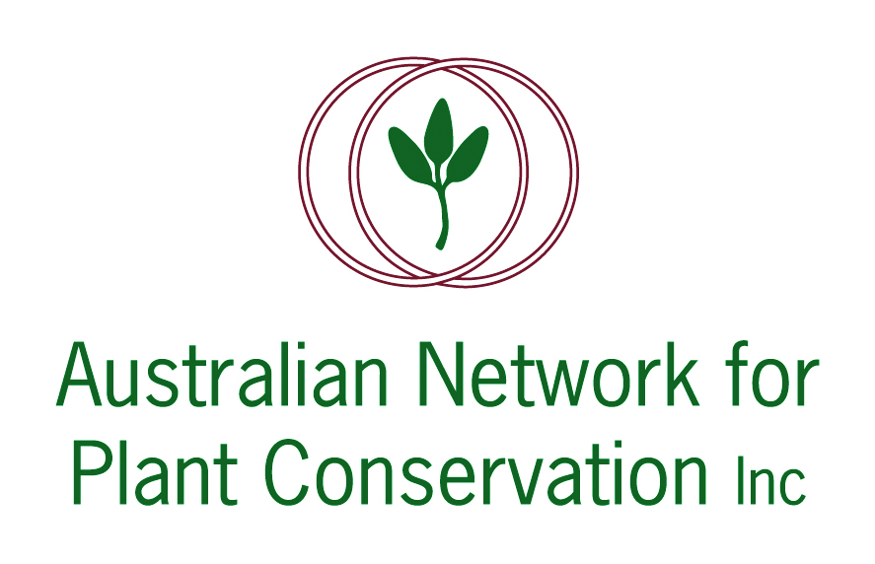

ABSTRACT: PLENARY LECTURE 2

An Australian’s first hand observations of the US seed production and restoration sectors.

Paul Gibson-Roy
Greening Australia NSW, PO Box 59, Broadway NSW 2007

The feasibility of restoring or reinstating Australian temperate grasslands and grassy woodlands has been much debated over the past decade by our sector. Despite good evidence having emerged during that time that this is possible with good success, relatively little has been achieved at large scale. The reasons for this poor outcome are varied; but ongoing doubts concerning techniques, limitations on seed resources, ongoing debates about provenance ranges and a lack of market drivers to support large-scale or long term projects are among the most obvious explanations. At the same time there have been ongoing reports of much greater successes restoring native grassy communities in the United Sates (from both the literature and from first-hand observations). This disparity in experience led Paul to apply for a Winston Churchill Memorial Trust Fellowship. The generous support of the Churchill Trust enabled him to tour the United States and observe firsthand that sector, with a particular emphasis on the producers of native seed.

His presentation will detail that tour, shedding light on the scale and structure of native seed production enterprises across a wide swath of the US. He will describe the production systems used to procure, grow and process native prairie seed and give insights into the different restoration outcomes made possible through this seed supply chain. Finally, he will discuss the various market drivers, which together create the opportunity for a seed production and restoration sector that far exceeds anything that currently exists in Australia. Paul's Fellowship demonstrates what is possible when market drivers are in place to support large scale restoration and provides a powerful counter point to the current Australian situation. It is hoped that insights from his Fellowship may provide pathways for our sector to move in more positive and constructive directions.

