12th Australasian Plant Conservation Conference

“Moving House – A New Age for Plant Translocation and Restoration”
11 - 15 November 2018, Canberra

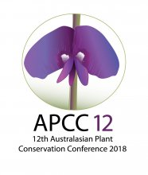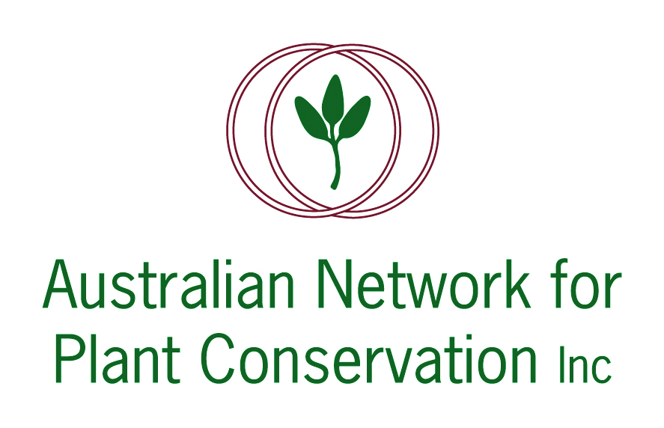

ABSTRACT: PLENARY LECTURE 5

'From a Burnt-Out Basement to a new Home in the Sun: The role of ecological consultants
in plant translocation.'
Belinda Pellow
Senior Botanist AMBS Ecology & Heritage
Ecological consultants work between legislation, development and biodiversity protection and this task requires a diverse set of skills. As part of the process we are increasingly called on to provide advice on threatened species management beyond avoidance and mitigation of impacts in situ. Removal of threatened plant species from a development footprint to an alternative location is now regularly recommended in impact assessments and required as a condition of development consent to offset impacts. However, these recommendations and decisions are seldom well informed by data on the likelihood of success or merit of alternative methods.
Consultants are called on to balance aspiration, realism, costs and client satisfaction in the context of limited scientific evidence, while also meeting our ethical obligations. Well-designed monitoring is needed to improve understanding of the translocation process and build knowledge on species-specific requirements. Sharing this information, however, can sometimes be challenging depending on the willingness of clients who own the data. Few mechanisms or economic incentives exist to make translocation data from development projects available. Other historical impediments include the lack of a central repository for translocation data and the absence of statutory responsibilities to maintain data on this important aspect of plant conservation.
Development of a systematic, publicly available information base of when, where and how plant translocations have succeeded or failed, and promoting the transfer of this knowledge should become important priorities for biodiversity conservation, particularly as translocations are increasingly relied upon to offset development impacts.

