12th Australasian Plant Conservation Conference

“Moving House – A New Age for Plant Translocation and Restoration”
11 - 15 November 2018, Canberra

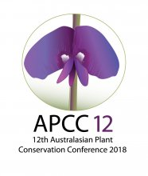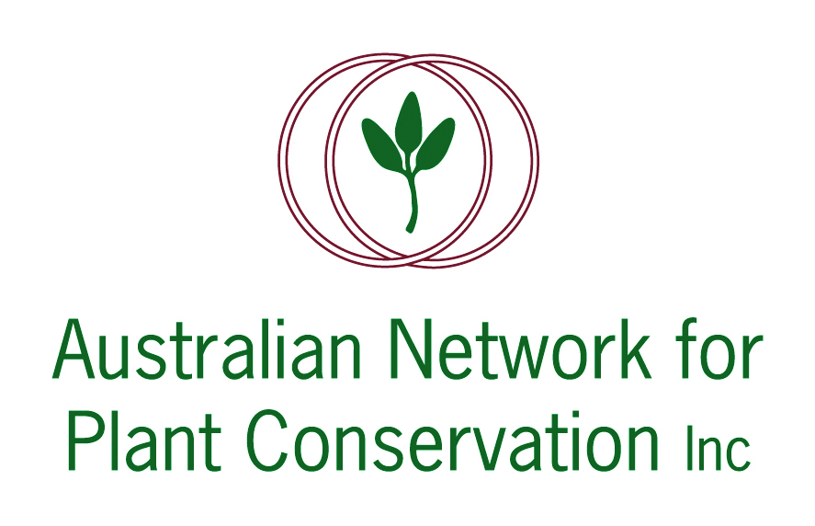

ABSTRACT: PLENARY LECTURE 6

‘Ex situ seed banks are a good investment as small deposits drive big returns.‘
Damian Wrigley
National Coordinator, Australian Seed Bank Partnership

Target 8 of the Global Strategy for Plant Conservation calls for 75% of known threatened plants to be secured in seed banks, with at least 20% available for restoration. This concept of seed use is a critical consideration for how seed banks can assist native plant conservation outcomes throughout Australia.

Often thought to be a static endeavour, focussed on securing and storing germplasm for some unforeseen future use, seed banking is a dynamic, complicated and exciting component of plant conservation capable of supporting restoration and translocation actions for our most threatened native species. Seed banking is an active and participatory science that involves strong collaborations across governments, industries and communities to strategically target collections and actively utilise these resources for immediate actions and long-term conservation outcomes.

Australia’s seed banking sector has compiled a wealth of information and expertise that already supports translocations and restoration actions across a wide range of landscapes using a rich diversity of species. Examples to be explored include a selection of the 50 translocations performed in WA using seed from the Threatened Flora Seed Centre as well as work by the WA Seed Technology Centre that focussed on Ricinocarpos brevis and Androcalva perlaria; a conservation partnership in South Australia’s Mount Lofty Ranges that used seed from a multitude of herbaceous species and typical sedges such as Chorizandra enodis and Carex inversa; an example from the Victoria Conservation Seedbank that saw Ballantinia antipoda produced in vast quantities over several seasons for translocations at select sites; and a project in NSW where the Australian PlantBank worked with government partners and the local community to successfully translocate Persoonia pauciflora both within and outside of its native range.

