12th Australasian Plant Conservation Conference

“Moving House – A New Age for Plant Translocation and Restoration”
11 - 15 November 2018, Canberra

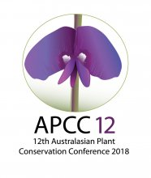

ABSTRACT: PLENARY LECTURE 5

‘Translocating threatened plants: linking policy, planning and practice.’
Peter Latch
Department of the Environment and Energy

Translocations of threatened species to support their recovery are important management responses that are increasingly being considered by threatened species managers across Australia. As with all management decisions, translocation requires considerable planning and must be considered within the mix of all potential interventions to meet the objectives of a threatened species recovery program. But given the legal protection afforded to listed threatened species, to what extent does legislation and policy inform or guide translocation decision making?

With reference to the state of Australia’s threatened plants, we will provide an overview of the national policy context, identifying to what extent national conservation plans identify translocation actions. With over 1300 nationally listed threatened plant species each with plans in place of varying age, length and detail, translocation actions where identified, vary greatly in their specificity and link to clearly identified objectives. This highlights the challenges in not only planning for translocation, but also in building a national picture of translocation effort and measures of success. With a number of new planning and policy initiatives underway, including the ANPC guidelines, there are opportunities to better plan for, and progressively build that national translocation picture as an integral part of broader conservation effort.

