12th Australasian Plant Conservation Conference

“Moving House – A New Age for Plant Translocation and Restoration”
11 - 15 November 2018, Canberra

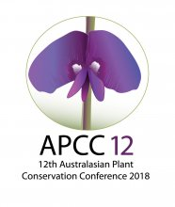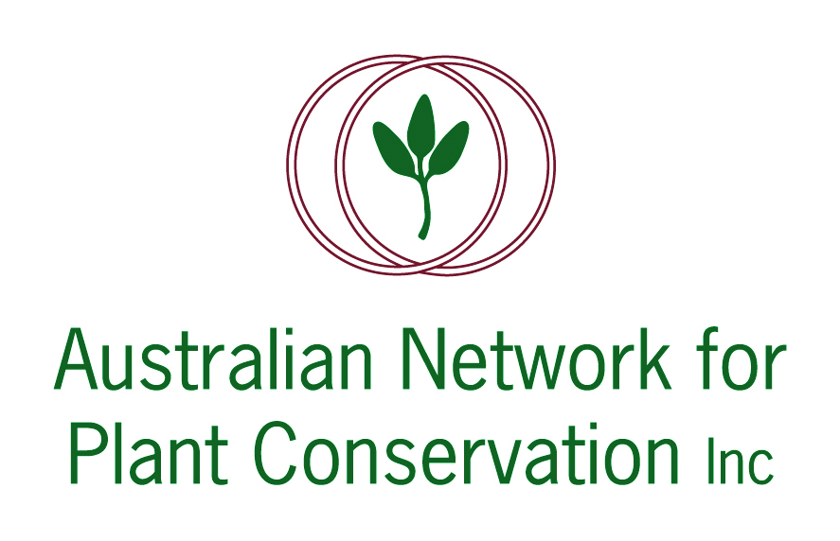

ABSTRACT: PLENARY LECTURE 4

‘Mammals – looking backwards, moving forwards.'
Dr Sarah Legge
Associate Professor; Principle Research Fellow ANU; UQ

Many Australian mammal species are highly susceptible to predation by introduced cats Felis catus and European red foxes Vulpes vulpes. These predators are the primary cause for Australia’s record of having the worst mammalian extinction rate in modern times and they continue to cause distributional and population declines for extant species. Deliberate translocations of mammals to cat- and fox-free islands and fenced havens have become an increasingly used option for protecting Australian mammals imperilled by cats and foxes.

We carried out an assessment of existing havens in Australia to assess the extent of their protection for the 67 threatened mammal taxa that are susceptible to cat/fox predation. Representation of taxa within havens was uneven, with some taxa represented in >10 havens, whilst other (29 taxa; 43%) are not represented in any havens. The haven network has grown through the de-centralised actions of many different government and non-government organisations, and private individuals. The network has substantially improved the conservation prospects of some species, but other species have missed out. We carried out a spatial optimisation analysis and found that a systematic planning approach to future network expansion could improve representation for all predator-susceptible mammal taxa. For example, by adding just 12 new havens, in the right place, we could protect at least one population of every predator-susceptible mammal taxon.

We reflect on the future for havens as a conservation tool for mammals: havens are critical for avoiding extinctions in the short-term, but they cover a minute proportion of species’ former ranges, and options for controlling the impacts of cats and foxes at landscape scales must be developed and implemented.

