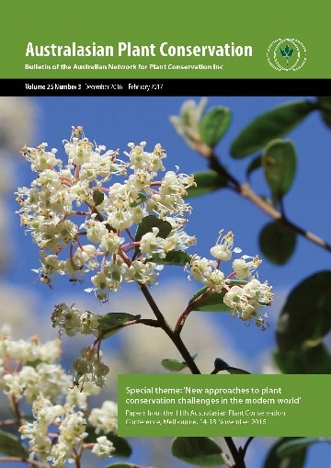

Australasian Plant Conservation

Advertising Fees 2018

All available in full colour!

Full page (A4) including back cover | Dimensions: 210mm w x 257mm h  File: Press Quality PDF or 300dpi TIF;  with 3mm bleeds + crop marks if applicable | $440
½ Inside back cover | Dimensions: 170mm w x 120mm h  File: Press Quality PDF or 300dpi TIF;  no bleeds/crop marks | $220
¼ page | Dimensions: 82.5mm w x 120mm h  File: Press Quality PDF or 300dpi TIF;  no bleeds/crop marks | $110
A4 insert (copies supplied) | Press Quality PDF;  with 3mm bleeds + crop marks if applicable | $440
A4 insert (copies not supplied) | Please enquire

(all prices include GST)

