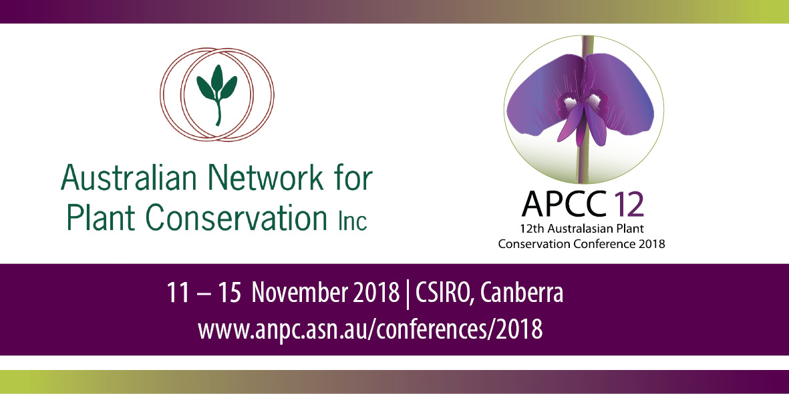

Registration Form and Tax Invoice
Deadline: Friday 2 November 2018
Please fill in your details below and tick all relevant boxes.
PARTICIPANT’S DETAILS:
If the participant is having their fees paid by someone else (e.g. employer) please also complete the payer’s details section.
Title: |  | First Name
Surname: |  | Position
Organisation: |  | PO Box/Street
Suburb/Town: |  | State
Post Code: |  | Daytime Phone
Mobile: |  | Email

I consent to my name, email address and organisation name being included in the list of participants for distribution to fellow participants. (The Privacy Act 2001 provides that you must give your consent for this.)
If the payer is NOT the conference participant please complete the following
Name: |  | Organisation:
Address:
Phone: |  | Email:

Dietary requirements
Vegetarian (may consume egg and/or dairy) |  | Gluten Free
Vegan |  | Other
Allergies

REGISTRATION
Notes:
- For those registering for two days of the conference, the Welcome Reception, Poster Session, Calendar and Translocation Guidelines are included. Please indicate if you will attend the Welcome Reception and Poster Session for catering purposes. Extra copies of the Calendar and Translocation Guidelines can be purchased.
- ‘ANPC member’ includes employees of an organisational member of the ANPC. List of corporate members can be found here http://www.anpc.asn.au/membership.
- Full-time students/unwaged are required to provide proof, for example, scan of student card, pensioner card, health care card etc.
- Both field trips include transport, lunch and snacks. BYO water bottles.

EVENT / PRODUCT | ANPC Member | Non-member | ANPC Member  F/T student/unwaged | Non-member  F/T student/unwaged
Welcome Reception & Guidelines Launch @ Synergy Sun 11 Nov 5.30-7.30pm  (free for those registering for 2 days) | $0 | $0 | $0 | $0
Welcome Reception & Guidelines Launch Extra ticket @ Synergy  Sun 11 Nov 5.30-7.30pm | $40 | $45 | $40 | $45
Two days conference  Monday 12 & Tuesday 13 Nov | $390 | $490 | $270 | $340
One day conference  Monday 12 Nov | $260 | $360 | $170 | $240
One day conference  Tuesday 13 Nov | $260 | $360 | $170 | $240
Poster Session  @ CSIRO Discovery Mon 12 Nov 5.30-7pm  (part of Day 1 registration only) | $0 | $0 | $0 | $0
Conference Dinner at Debacle, Braddon Tuesday 13 Nov 7pm onwards  (includes one drink) | $45 | $50 | $40 | $45
Extra Conference Dinner ticket | $45 | $50 | $40 | $45
Plant Translocation Workshop  Wednesday 14 Nov 9am – 5pm | $130 | $150 | $80 | $100
Field Trip 1 – full day  Threatened plant translocation projects  Thursday 15 Nov 9am – 5pm | $180 | $210 | $120 | $150
Field Trip 2 – half day  Barrer Hill Woodland Restoration Project  Thursday 15 Nov 9am – 1pm | $90 | $105 | $60 | $75
Tour 1 – half day  Australian National Herbarium & Australian National Insect Collection  Thursday 15 Nov, Time 10am – 12.15pm Limit of 15 (free) | $0 | $0 | $0 | $0
Tour 2 – half day  Australian National Botanical Gardens & National Seedbank  Thursday 15 Nov, Time 1.30 – 3.30pm  Limit of 15 | $10 | $15 | $10 | $15
2019 ACT Threatened Plants Calendar  (free for those registering for 2 days - to be picked up at conference) | $0 | $0 | $0 | $0
2019 ACT Threatened Plants Calendar Extra copy (to be picked up at conference) | $10 | $15 | $10 | $15
3rd Edition of Translocation Guidelines  (free for those registering for 2 days and/or Workshop, to be picked up at conference | $0 | $0 | $0 | $0
3rd Edition of Translocation Guidelines Extra copy (to be picked up at conference) | $22 | $27 | $22 | $27
Total | $ | $ | $ | $

PAYMENT DETAILS: - GST inclusive. A Tax Invoice/Receipt will be issued.
Total: | $
Direct Credit: |  | Description: | APCC12 + your name
Account Number: | 139397830 | BSB: | 633000
 |  | Account Name: | Australian Network for Plant Conservation
Invoice my organisation: |  | Purchase order number:
Cheque/Money order: |  | Made out to: | Australian Network for Plant Conservation Inc.
Visa: |  | Master Card:
Expiry Date: | / | Card Number: | / / /
3 Digit Code: |  | Name on Card:

SEND YOUR REGISTRATION FORM TO: (Please keep a copy for your records).
Email: anpcstaff-generic@environment.gov.au or Post: ANPC, GPO Box 1777, Canberra ACT 2601
Fax: 02 6250 9599

Cancellation policy:
A $60 administration fee applies if a participant cancels their conference registration before 2 November 2018.
No refund will be given after this date however a replacement will be accepted.

ANPC Office Use Only:
Recorded Membership ID Officer Date / /
Xero: Inv # RN CR# Date / /
ABN 70 861 480 818 APCC12-070918

