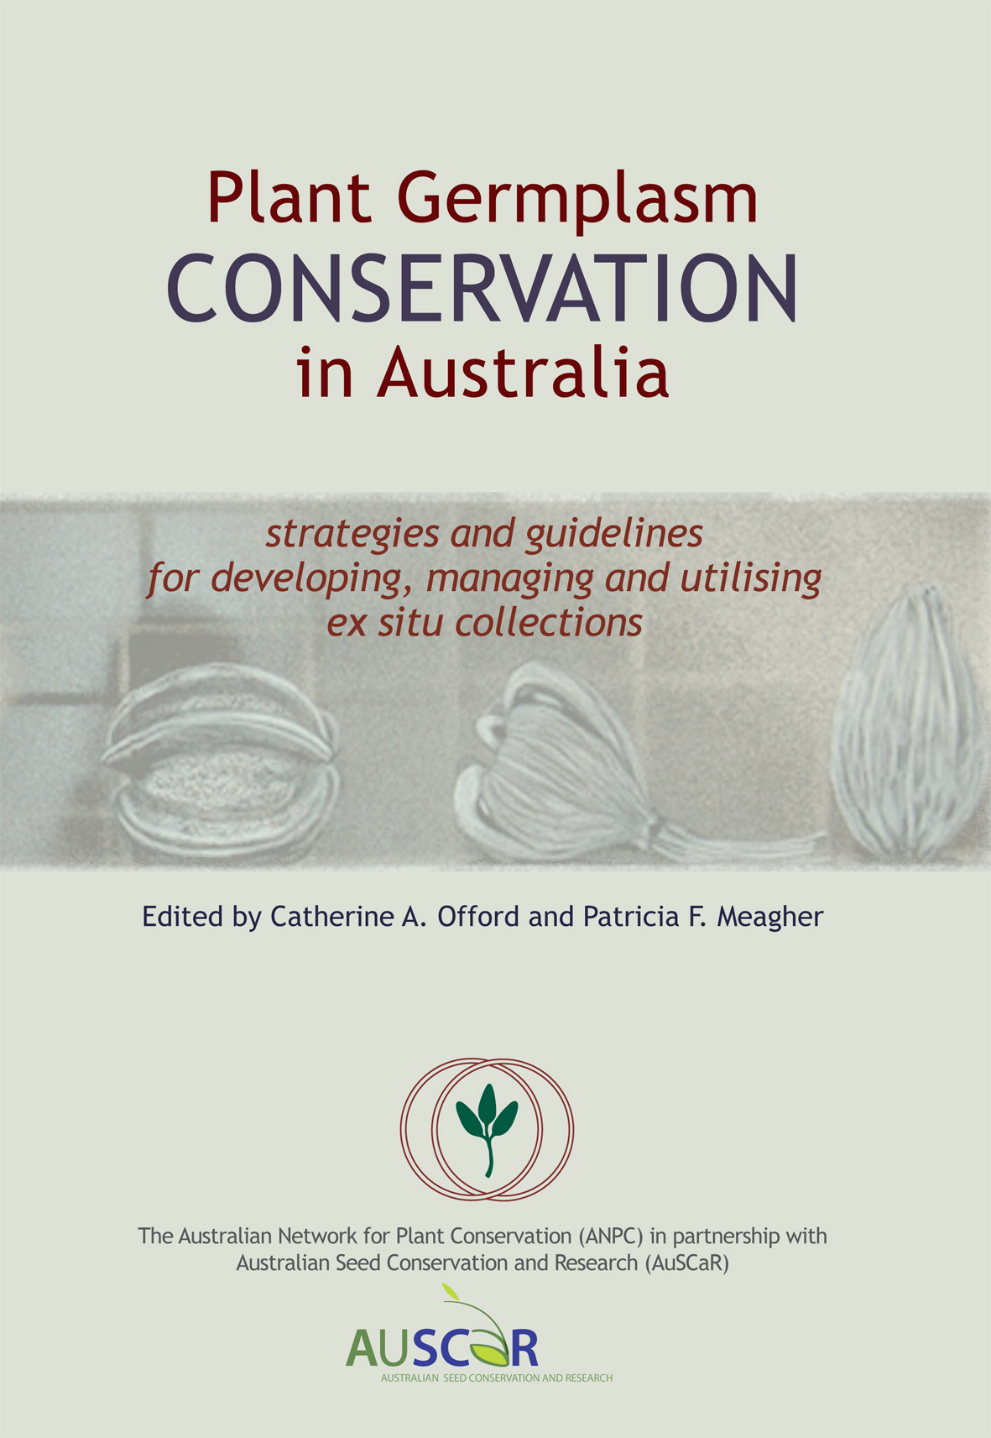

Australian Network for Plant Conservation Inc
Plant Germplasm Conservation in Australia
Fax: (0)2 6250 9599
Order Form
NEW PRICES NOW AVAILABLE!

NEW release e-version (pdf file):  Non- Members  - NEW e-version $5.00 for individual sale  - A pdf file is sent by email on receipt  of payment  - Non-members may sign up as a new member and receive this free of charge  - How to become a member: www.anpc.asn.au/membership  ANPC Members  - New e-version Free of charge for all ANPC members – no payment required  - The free e-version will be supplied to members upon completion of membership renewal forms  - A pdf file is sent by email on receipt of payment  - New members receive this free of charge after joining  - How to become a member: www.anpc.asn.au/membership | Plant Germplasm Conservation In Australia. | QTY | TOTAL
 | NEW PRICE PRINTED VERSION - $15.00  AUSTRALIAN ORDERS –  (inc $10 postage within Australia)  Plant Germplasm Conservation in Australia.  Price reduced from $49.95 per copy as of 26/07/2016 | x | $
 | NEW PRICE PRINTED VERSION – $45.00  INTERNATIONAL ORDERS -  (inc $30 international postage)  Plant Germplasm Conservation in Australia.  Price reduced from $64.95 per copy as of 26/07/2016 | x | $
 | NEW E-VERSION – $5.00  NON-MEMBER  NEW e-version (PDF file)  Australia + International orders  Germplasm Conservation in Australia. | x | $
 | NEW E-VERSION - $0.00 FREE  MEMBERS ONLY  NEW e-version (PDF file)  Australia + International orders  Germplasm Conservation in Australia. | x | $
When completed you can save and email this form to anpc@anpc.asn.au, or print and send this form to: Australian Network for Plant Conservation Inc, GPO Box 1777, Canberra ACT 2601, Australia.
Title |  |  | First name |  |  |  |  |  |  | Surname |  |  | Organisation
Delivery address
Suburb/Town |  |  |  |  |  |  |  |  |  | State |  |  |  |  | Postcode |  |  |  |  | Country
Phone W |  |  |  |  |  |  |  | Email |  |  |  |  |  |  |  |  | Mobile
Total Amount: $
Direct Credit: BSB: 633000 Account #: 139397830 Bank: Bendigo Reference: (your name)
Account name: Australian Network for Plant Conservation
Visa MasterCard Reference: (your name)
Card Number |  |  |  | / / / |  |  |  |  |  |  |  | Expiry Date |  |  |  | / |  |  |  |  | 3 digit code
Name on Card |  |  |  |  |  |  |  |  |  |  | Cardholder’s signature
Cheque/Money order made out to “Australian Network for Plant Conservation Date sent by post
Office Use Only:
Order received ___/____/____ Order sent ___/____/__ MYOB Inv #_________ Date ___/____/__
MYOB RN_________ Date _____/_____/_____ MYOB CR #_________ Date____/____/____ Order recorded 

