
Australian Network for Plant Conservation Inc
Plant Conservation: approaches and techniques
from an Australian perspective
CD Version
Order Form

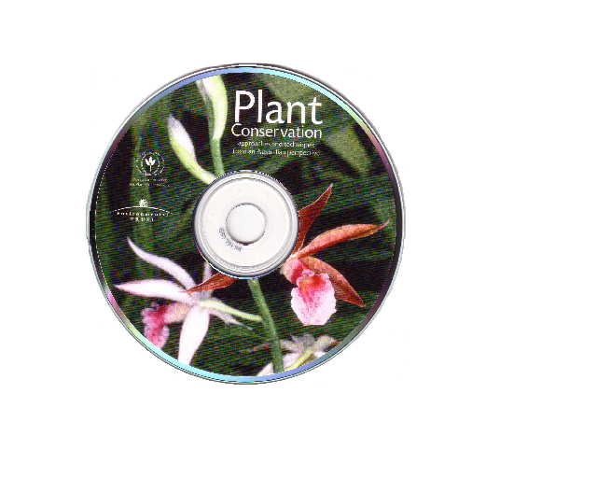
Price each AUD $30.00 now $15.00

Postage and handling: Australia included or International $AU5.00ea

Note: This manual continues to be a valuable resource however some modules are becoming dated. We are therefore offering the CD at a discount price.

When completed you can save and email this form to: anpc@anpc.asn.au

Or print and send the form to:
Australian Network for Plant Conservation Inc
GPO Box 1777
Canberra, ACT, 2601, Australia
Fax (02) 6250 9528

Price Postage Subtotal Qty TOTAL
$15.00 + $0.00 = $15.00 x = $ In Australia
$15.00 + $5.00 = $20.00 x = $ International
Name: Organisation:
Delivery address:
Suburb/Town: State: Postcode: Country:
Phone: W Email:
My cheque /money order for $AUD (payable to Australian Network for Plant Conservation Inc) is enclosed,
or charge my Visa Mastercard
Name on Card
Card Number: / / / Expiry Date: / 3 digit code
Signature.........................................................................................................................................................................................
Office Use Only:
Order received ___/____/____ Order sent ___/____/__ MYOB Inv #_________ Date ___/____/__
MYOB RN_________ Date _____/_____/_____ MYOB CR #_________ Date____/____/____ Order recorded 

