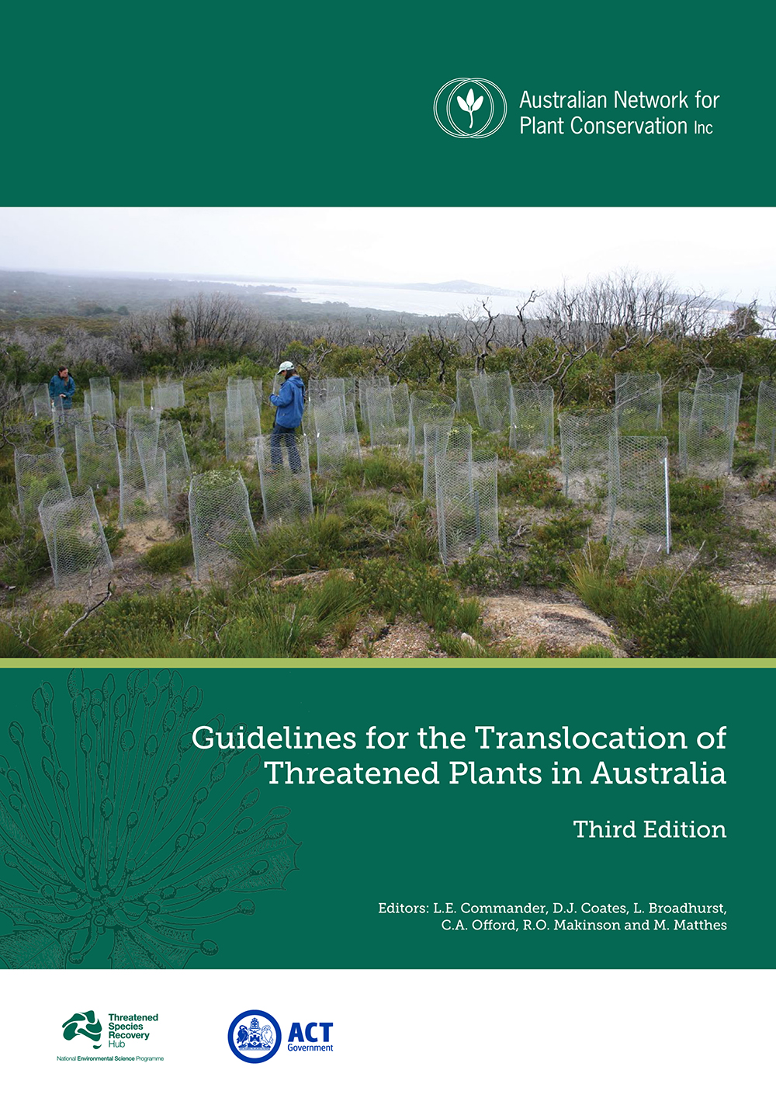

Australian Network for Plant Conservation Inc
Guidelines for the Translocation of
Threatened Plants in Australia
3rd edition

Order Form - APCC12 early-bird price!

Price each AUD $27.00 or
$22.00 for ANPC Members

Postage and handling: Australia $AU 10.00ea

International $AU 30.00ea
NB. ‘ANPC Members’ includes employees of an organisational member of the ANPC. The list of corporate members can be found here http://www.anpc.asn.au/membership
Guidelines for the Translocation of Threatened Plants in Australia – 3rd edition | QTY | TOTAL
ANPC MEMBERS - $22.00 each  + Postage and handling - Australia $10.00 per copy OR  + Postage and handling - International $30.00 per copy | x  x  x | $  $  $
Non-ANPC MEMBERS - $27.00 each  + Postage and handling - Australia $10.00 per copy OR  + Postage and handling - International $30.00 per copy | x  x  x | $  $  $
TOTAL | x | $
When completed you can save and email this form to anpc@anpc.asn.au, or print and send this form to: Australian Network for Plant Conservation Inc, GPO Box 1777, Canberra ACT 2601, Australia.
Title |  |  | First name |  |  |  |  |  |  | Surname |  |  | Organisation
Delivery address
Suburb/Town |  |  |  |  |  |  |  |  |  | State |  |  |  |  | Postcode |  |  |  |  | Country
Phone W |  |  |  |  |  |  |  | Email |  |  |  |  |  |  |  |  | Mobile
Total Amount: $
Direct Credit: BSB: 633000 Account #: 139397830 Bank: Bendigo Reference: (your name)
Account name: Australian Network for Plant Conservation
Visa MasterCard Reference: (your name)
Card Number |  |  |  | / / / |  |  |  |  |  |  |  | Expiry Date |  |  |  | /
Name on Card |  |  |  |  |  |  |  |  |  |  | 3 digit code
Cheque/Money order made out to “Australian Network for Plant Conservation Date sent by post
Office Use Only:
Order received ___/____/____ Order sent ___/____/__ Xero Inv #_________ Date ___/____/__
Xero RN_________ Date _____/_____/_____ Xero CR #_________ Date____/____/____ Order recorded 

