

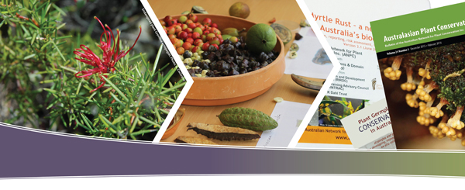
AUSTRALASIAN PLANT CONSERVATION
Instructions for authors
last updated 22nd March 2019

ABOUT THE AUSTRALASIAN PLANT CONSERVATION BULLETIN

What is the Australasian Plant Conservation bulletin?

Australasian Plant Conservation (APC) - the quarterly bulletin of the Australian Network for Plant Conservation (ANPC) - is a forum for information exchange for all those involved in plant conservation, whether in research, management, or on-ground practice, and where they can share their work with others. Each issue contains a range of articles on plant conservation issues, usually on a particular theme, which reflect the interests of the range of ANPC's membership. However, off-theme articles are welcome at any time. Regular features include lists of the latest relevant publications, membership profiles, Australian Seed Bank Partnership news, and conference and workshop reports.

APC publishes articles from the breath of fields that inform plant conservation in Australalasia, including, but not limited to, ecology, botany, conservation biology, aquatic botany, bryology, mycology, restoration, horticulture, social science (e.g., community environmental management), natural resource management and environmental policy.

The role of APC is to provide a common forum accessible to scientific researchers, land and natural resource managers and ecological consultants, and community practitioners. APC is a great way for scientists to communicate their findings to practitioners, and conversely for practitioners to report their work and practical issues in a scientific forum; an important part of APC’s role is to provide an avenue for practitioners with limited or no scope for publication in their field. Student and trainee papers are encouraged, as are papers from our Australasian neighbours (e.g., New Zealand, Papua New Guinea, New Caledonia). To the extent possible, and with the exception of policy articles, we prefer material which includes at least indicative results and some attempt to identify generalisable results (not simply ‘we did this’, but ‘here’s what it means in our situation’).

APC is not a ‘peer-reviewed’ journal, but it is edited to a high scientific and technical standard, in liaison with authors as necessary. We seek to operate at the interface of the science and management of plant conservation, publishing information which can be applied to improve plant conservation.

We ask authors to keep our broad readership in mind – we seek articles that are as far as possible ‘plain-English’, without being dumbed down. Please take space in your draft to briefly explain (rather than assume) technical terms or concepts, or local situations, that may be unfamiliar to other sections of the readership. Please discuss with the editor if in doubt.

APC is published quarterly, and is provided free to ANPC members within Australia and worldwide as part of their subscription.

What types of articles are published?
- Articles (usually <1200 words).
- Information snippets, details of new publications or research, and diary dates.

What are the fees involved?

- We do not charge for article submission and/or proof reading and edits.
- Our editor and proof reading team will check your content, however we ask that you proof your own work before submitting your article.
- If the ANPC feel that a section, or all of the content is not suitable, you will be contacted.

Special Offer

If you submit an article to the APC you will receive:
- Complimentary copy (x1) of the printed and e-version of APC (that includes your article).
- Complimentary hard copy (if required) – Plant Germplasm Guidelines.

DEADLINES

The deadline for article submissions is available on the ANPC website www.anpc.asn.au/apc. Article enquiries should be addressed to the editor at editor@anpc.asn.au.

CONTACTS

Australasian Plant Conservation

Editor
Paul Adam

Incoming Editor (2018)
Heidi Zimmer

Joint contact: editor@anpc.asn.au

ANPC office
GPO Box 1777
Canberra, ACT 2601, Australia
T (02) 6250 9509 | F (02) 6250 9599
E anpc@anpc.asn.au
W www.anpc.asn.au

 | Australian Network for Plant Conservation Inc.  GPO Box 1777, Canberra, ACT, 2601, Australia  Telephone: +61 (02) 6250 9509; Fax: +61 (02) 6250 9599; Email: business@anpc.asn.au  Website: http://www.anpc.asn.au  ABN 70 861 480 818

ARTICLE SUBMISSION FORM

Contributing to Australasian Plant Conservation ISSN 1039–6500

PLEASE ATTACH A COMPLETED AND SIGNED ARTICLE SUBMISSION FORM TO ALL ARTICLE SUBMISSIONS. ARTICLE SUBMISSION FORMS CAN BE COMPLETED ELECTRONICALLY OR BY HAND, AND SUBMITTED ELECTRONICALLY (i.e., as a pdf) OR BY POST TO THE ANPC OFFICE.
Opinions expressed in this publication are those of the authors and are not necessarily those of the ANPC
or its sponsors. Material presented in Australasian Plant Conservation may be copied for personal use or published for educational purposes, provided that any extracts are fully acknowledged. Where any material is credited to and/or copyright to another source we encourage that you contact the original source for permission to reprint.

As an author and/or advertiser for the Australasian Plant Conservation, you agree the content you provide is relevant and appropriate for the purpose of printing or advertising and that you take responsibility for the material published by the Australian Network for Plant Conservation Inc.
We understand in receiving your submission that you have gained the appropriate approvals to publish the content provided and you understand the Australian Network for Plant Conservation is not liable for the content and graphics and/or images published.

Please sign and date your approval as indicated:  In signing this form, you agree that you have gained the relevant permissions to publish your content in Australasian Plant Conservation prior to article/content submission.  Where images (photos or otherwise) are from a source other than the author(s) evidence should be provided that approval has been received to use the images. | Content approval (article and/or advert)  Image approval  Additional graphs, charts and/or general  graphics  Approval  Name (please print):  Signature:....................………………………………………  Date:

Article submission:
Please complete this section if you are supplying an article for the APC bulletin.

Name of Author
Lead Author Contact details: | Name (please print):  Email:  Contact Phone:
Other Author Name(s):
Article Title:
Volume/Edition Number: Refer to the article submission table at www.anpc.asn.au/apc

Unless related to a specific theme we may, if space is tight, move general articles to the following issue

Images provided (separately)?  Note: Images will not be accepted if they are embedded into your text (MS Word) file.  Your word file must specify the image file name either in-text, or within the list of figure captions at the end of your document. Please name the photo figure following the convention “Authorname_Photo1” or “Authorname_Fig1” (e.g., Smith_Fig1). | Yes No
Images size/resolution:  Have you supplied your image(s) according to the print requirements (300dpi)? | Yes No
Charts/Graphs:  Additional charts/graphs supplied (separately):  Pending space available, our designer may illustrate a version suitable for our style with further approval required. | Yes No
Do you agree for the ANPC to adjust the artwork for further approval? (Authors approval of any adjustments will be sought before publication.)  Please provide the best contact for the purpose of adjustments to the artwork: | Yes No  Name (please print):  Email:  Contact Phone:

By submitting your manuscript to APC you agree that the reported research has followed an approved ethical methodology (if required), especially with regard to human subjects. Permit numbers should be reported after the acknowledgements section.

Please note that APC article proofs are not provided to authors unless they are specifically requested. If you would like to receive the proof of your article before it is published please request this by writing a separate email directly to the Editor (editor@anpc.asn.au).

FOR OFFICE USE ONLY
Date received: ……/...…/…….. Officer: ……………………..... Final approvals gained (Date): ………………
Content approval – Editor: Date received: ……/...…/……..

Complimentary e-version sent on completion with complimentary Germplasm Guidelines sent: : ……/...…/……..
Complimentary copy sent on completion via Australia Post: ……/...…/……..

Australian Network for Plant Conservation Inc.
GPO Box 1777, Canberra, ACT, 2601, Australia
Telephone: +61 (02) 6250 9509; Fax: +61 (02) 6250 9528; Email: business@anpc.asn.au
Website: http://www.anpc.asn.au
ABN 70 861 480 818

APC ARTICLE TEMPLATE

Article title [style = APC H1 title]
Author/s name [style = APC author]
Author/s affiliation [style = APC author affiliation]
Heading [style = APC H2 heading]
Sub heading [style = APC H3 subheading]
Article text [style = APC body text]
- Bullet [style = APC bullet]
- Numbered bullet [style = APC bullet numbered]
References [style = APC references]
Image caption [style = APC caption]

APC Editorial Guidelines / Instructions for authors

AUTHOR CHECKLIST:
Please use this checklist to ensure you meet the requirements for article submission(s):

ARTICLE STYLE INFORMATION:
Adherence to the following guidelines assists considerably in the editing of APC.
Articles should be in a style readily accessible to the diverse readership.

Please explain any technical terms that are of restricted usage, in text, at their first use.

Articles are one to three pages (usually a maximum of 1200 words, including references and tables). Please note tables are limited to space available and you will be contacted if your requirements exceed this limit.

ELECTRONIC FILE FORMAT / TEMPLATE DOWNLOAD
Please submit articles as electronic files in MS Word or in rich text format (rtf).

Send articles, images and logos to the editor (editor@anpc.asn.au). If you have any problems please contact the ANPC office (anpc@anpc.asn.au).

The article template can be downloaded from our site – Article Template: http://anpc.asn.au/apc .

REFERENCES:
Please keep referencing to a minimum (usually no more than five references). Restrict to essential/key references.

Registered Trademark applied when required. ® ™

All items in the reference list must be readily available.

Do not give the part number with the journal volume number unless parts are separately paginated (except in Research roundup).
Spell out journal title in full.

SPELLING AND GRAMMAR:
- Use Australian English, so ‘colour’ not ‘color’, and use ‘s’ not ‘z’ in words such as ‘organisation’, ‘recognise’ etc. (unless, for example, in titles of already published documents in reference list).
- Spell out all numbers less than 10. For example, “three” rather than “3”, unless it is followed by a unit, for example, 3 km.
- Formal species listing status should be capitalised (e.g., Critically Endangered, Endangered or Vulnerable) and relevant jurisdiction or government act (e.g., IUCN Red List, NSW Biodiversity Conservation Act) given at first mention.
- Seasons should not be capitalised (e.g., summer, autumn).
- Place a space between number and unit (i.e., 3 km).
- There should be no spaces beside symbols +,- and ~ when they are followed by a number. There should also be no spaces beside forward and back slashes (e.g., and/or).
- No full stop is required after abbreviated titles (i.e., use 'Dr' rather than 'Dr.').
- For subspecies, please use 'subsp.' rather than 'ssp.'
- *Direct quotations may be exempt from this rule.

COMMON NAMES AND NOMENCLATURE:
Provide scientific names in brackets after the common name the first time the species is mentioned. Currently accepted scientific name should be used as agreed by the Council of Heads of Australasian Herbaria (CHAH) in the Australian Plant Census (http://www.anbg.gov.au/chah/apc/). APCensus usage is preferred, unless there is a case for variant usage to suit a State-specific or international context – in this case please make the nomenclatural equivalences explicit

Orcid Identifier, if used, should be listed underneath the author’s email address.
Common names should be capitalised, as in: Red Box, Grand Spider-orchid, Rainbow Plant.
Use of italics - In cases where it helps clarity of expression, and simple capitalisation does not suffice, authors may use single inverted commas or italic font for titles (especially where long) of publications, programs, or projects, to delimit these from the surrounding text.

SAMPLES OF APC LAYOUT, SCOPE AND GENERAL STYLE
Title  Capital letter only for first word and proper nouns. No full stop at end of title.  The name, organisation and state should appear (but no full postal address, or country (if within Australia)). | 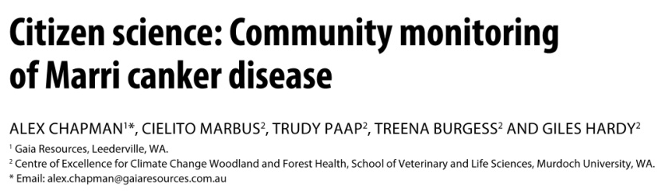
Names and details of author/s  Spell out first names | 
Email details
Required for at least one author. Please put email address in a separate sentence (not followed by full-stop).
Text flow  Please submit your document with single spacing. | 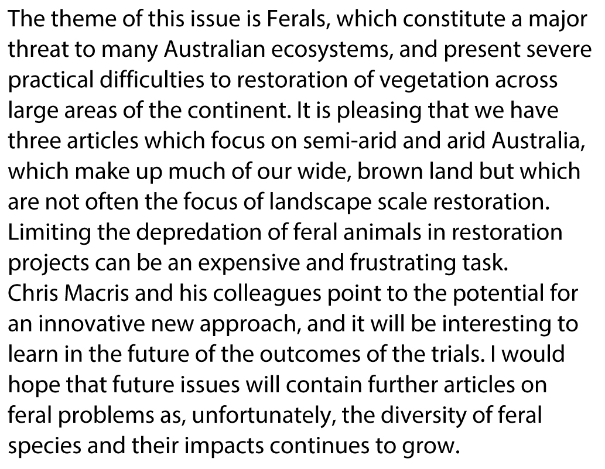
Use of subheadings  We encourage the use of subheadings. Capital letter only for first word and proper nouns. No full stop at end of subheading. | 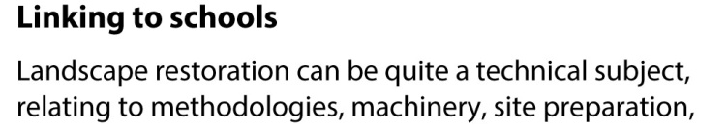
Paragraph style  Each paragraph should be separated by a blank line, and not indented.  Use one space after each sentence and single ‘quotes’. | 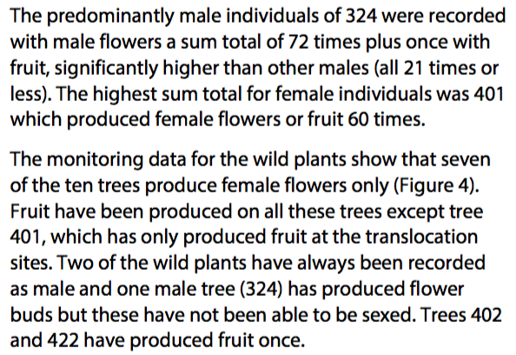
Lists with bullets  It can be useful to present information as lists with a series of bulleted entries as follows:  • The text before the list ends with a colon.  • One line spacing after each entry.  • First word of each entry capitalised.  • Full stop after each entry. | 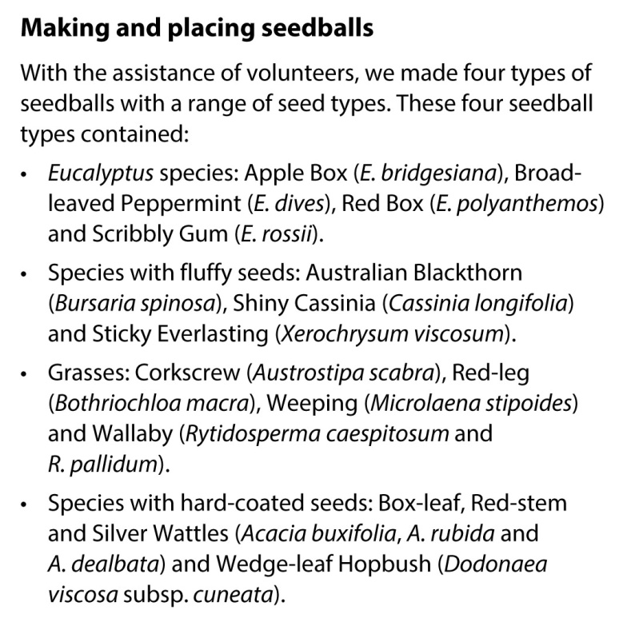
Abbreviations
Spell out when first used e.g., “Australian Network for Plant Conservation (ANPC)” then in every other position throughout your article it can remain “ANPC”.

Do not use full stops in abbreviations made up of capital letters (e.g., ACT, ANPC).

Species names should be abbreviated after first use (e.g., Themeda triandra to T. triandra), although exceptions should be made if writing species name in full improves clarity, and if the species name occurs at the beginning of a sentence (e.g., The site was dominated by T. triandra. Themeda triandra is a native perennial grass).
Latin abbreviations
Use (in italic font): “et al.”, “ex situ”, “in situ”, “e.g.,” and “i.e.,”.
Spelling
Use Australian English, so ‘colour’ not ‘color’, and use ‘s’ not ‘z’ in words such as ‘organisation’, ‘recognise’ etc.
Images Authors are encouraged to submit images with articles.  Please ensure the photograph is clearly associated with a photo credit, including the photographers full name (i.e., within the figure caption).  Please ensure images are 300 dpi resolution, and that they are submitted in at least the size that they are to be published, in tif, jpg or gif format.  Please send each image to the editor as a separate file (not embedded in the text).  Please name each separate figure/image file with the manuscript author’s name and a figure number (e.g,. “Smith_Fig1”).  If you would like your images to go with a certain block of text please indicate this within the text, otherwise they will be inserted where they fit best. | 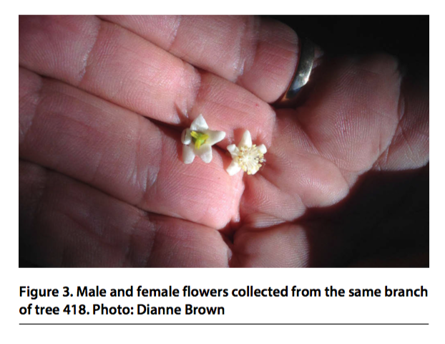
Image caption  Each image should have an explanatory caption, which includes the photo credit (with the photographers full name).  Each figure caption should make sense without the need to read the accompanying text.  Scientific names should be in italics.  Refer to figures in text as “Figure 1” rather than “Fig. 1”.  Text for figure/photo captions and credits should be on a separate page at the end of the text document, and refer to the file name of each image.  Cover images need to be of high resolution (to be reproduced as A4 image). | 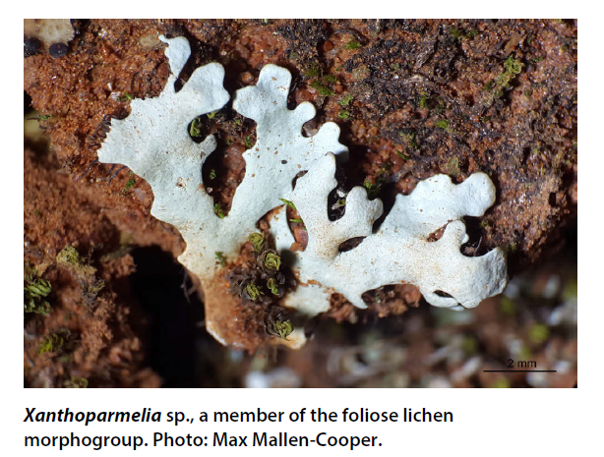
Graphs  If you have used an excel graph please supply the original excel file separately. Please name each excel file with the article author’s name and figure number (e.g., “Smith_Fig6”). | 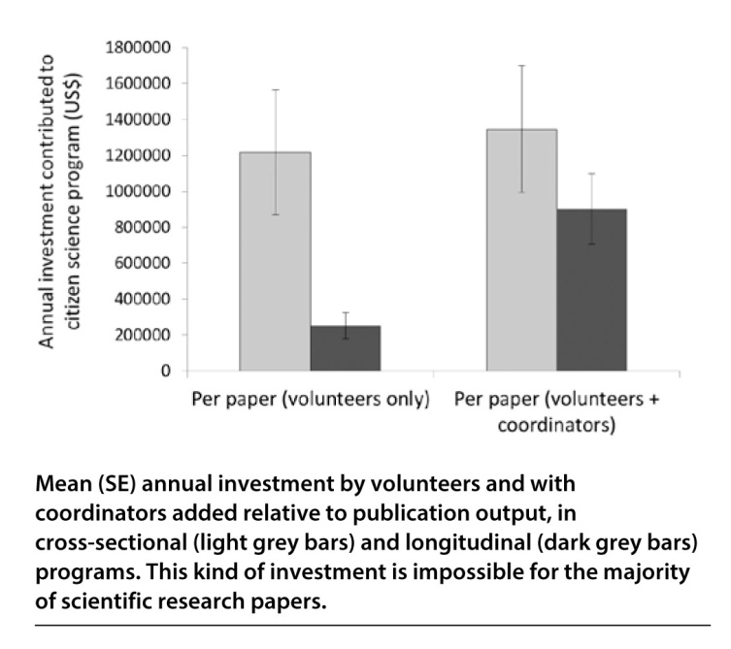
Tables
Tables should include horizontal lines only (no vertical lines). Each table should have a title/caption, given above the table.

Each table caption should make sense without the need to read the accompanying text.

References  Please keep referencing to a minimum (usually no more than five references) and restrict to essential/key references.  All items in the reference list must be readily available.  Please pay particular attention to formatting of author list (i.e., abbreviation of first names, spacing within abbreviations), presentation of year (in brackets, followed by full stop), italicisation of some fields (varying with reference type) and the use of “and” rather than “&”.  Incorrectly formatted references will be returned to the author for re-formatting.  If websites or email addresses are cited in the main body of the text they should be bold formatted.  Please note: the referencing of articles differs to that within the APC section “Research Round up”. | Journal article:  Constanza, R., D’Arge, R., De Groots, R., Farber, S., Grasso, M., Hannon, B., Limburg, K., Naeem, S., O’Neil, R.V., Paruelo, J., Raskin, R.G., Sutton, P. and Van Den Belt, M. (1997). The value of the world's ecosystem services and natural capital. Nature 387: 253-260.  Online journal article:  Kriticos, D. J., Morin, L., Leriche, A., Anderson, R.C., and Caley, P. (2013). Combining a climatic niche model of an invasive fungus with its host species distributions to identify risks to natural assets: Puccinia psidii Sensu Lato in Australia. PLoS ONE 8(5): e64479. https://doi.org/10.1371/ journal.pone.0064479  Book:  Briggs, J.D., and Leigh, J. H. (1996). Rare or threatened Australian plants. CSIRO Publishing, Melbourne.  Section or chapter within a book:  Erickson, T.E. and Merritt, D. J. (2016). Seed collection, cleaning and storage procedures. In: Erickson, T.E., Barrett, R.L., Merritt, D.L. and Dixon, K.W. (Eds.) Pilbara seed atlas and field guide: plant restoration in Australia’s arid northwest. pp. 7-116. CSIRO Publishing, Melbourne.  Report (available online):  Hancock, N., Harris, R., Broadhurst, L. and Hughes, L. (2016). Climate-ready revegetation. A guide for natural resource managers. Macquarie University, Sydney. Available at: http://anpc.asn.au/resources/climate_ready_revegetation  Report (not available online):  Sattler, P. and Williams, R. (1999). The conservation status of Queensland’s bioregional ecosystems. Environmental Protection Agency, Queensland Government, Brisbane.  Thesis:  Hall, K.B. (2015) Modeling the actual productivity of Eucalyptus benthamii in the Southeastern United States. Thesis for degree of Master of Science, Forestry and Environmental Resources, Raleigh, North Carolina.  Website:  Australian Government (2016) ‘EPBC Act List of Threatened Flora’ (Australian Government Department of the Environment: Canberra). Available at: http://www.environment.gov.au/cgi-bin/sprat/publicthreatenedlist.pl?wanted-flora
In-text citations  In the text, references should be in chronological order. Multiple references should be separated by semi colons. Use “and” where there are two co-authors and “et al.” where there are more than two co-authors. Do not use a comma between author name and year.  Government Acts should be italicised (e.g., Environment Protection and Biodiversity Conservation Act 1999). | 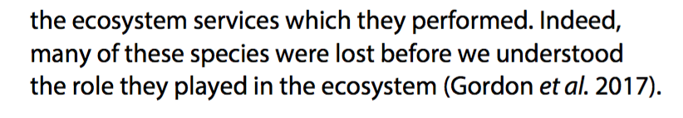  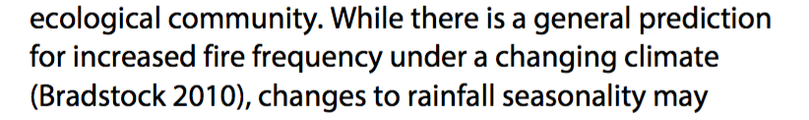
Acknowledgements and conflicts of interest
A conflicts of interest section can also be included after the acknowledgements section, identifying any financial, political, personal or professional relationships that may be understood to have influenced the manuscript. Sources of funding should be declared within the acknowledgements section.

