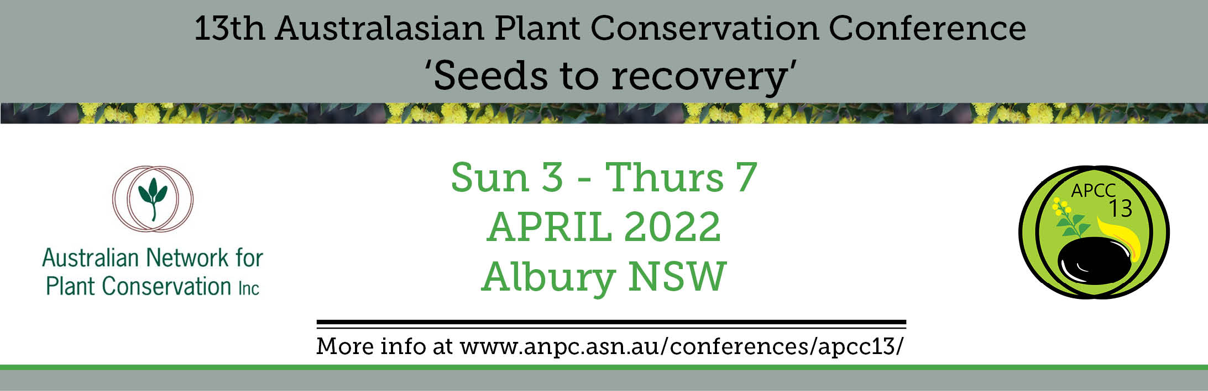

Abstract submission form – due 25 February 2022
Please use this form to submit an abstract for a conference presentation or poster.
To complete the form: type details in the boxes, save, print for your records, then send by email
to business@anpc.asn.au. Alternatively post the completed form to the ANPC contact details listed below.

PRESENTER DETAILS

Title First Name Surname
Current Position Organisation

Co-author(s)
PO Box/Street address
Suburb/Town State Postcode
Daytime phone Mobile Email
Presenter’s biography (maximum 40 words)

ABSTRACT SUBMISSION

Will you be presenting:
In person (at Albury Entertainment Centre) (or) Online
Presentation (or) Poster
I would like my abstract to be considered for the following plenary theme(s) (please tick):

Seeds

Bushfire recovery

Conservation/ threatened species and communities

Engaging people with conservation / restoration
Open forum (no theme)

I would like my abstract to be considered for a 5-10 minute (TBC) presentation at the following workshop (please tick):

Meeting ambitious goals in the ‘UN Decade on Ecosystem Restoration’: national, state, regional and local
scale

Selecting species and provenances: a showcase of tools and approaches
Best-practice guidelines and methods of plant replacement: presentations and panel discussion

For more details on the plenary themes and workshops, please refer to our website https://www.anpc.asn.au/conferences/apcc13/

Tick here if you are prepared to submit a full-length paper (approx. 1200 words) for publication in Australasian Plant Conservation (you will be contacted by the editor prior to the conference). The deadline for this is 1 May 2022. Email editor@anpc.asn.au for any queries about submission of full-length papers.
Proposed title of presentation / poster:

Abstract (maximum 250 words):

Note: Please submit abstracts via email to business@anpc.asn.au by Friday 25 February 2022.
Abstracts should be no more than 250 words in length.
All abstracts will be made available online for download by conference participants.

Australian Network for Plant Conservation Inc.
GPO Box 1777, Canberra, ACT, 2601, Australia

Telephone: +61 (02) 6250 9509
Email: business@anpc.asn.au
Web: www.anpc.asn.au

