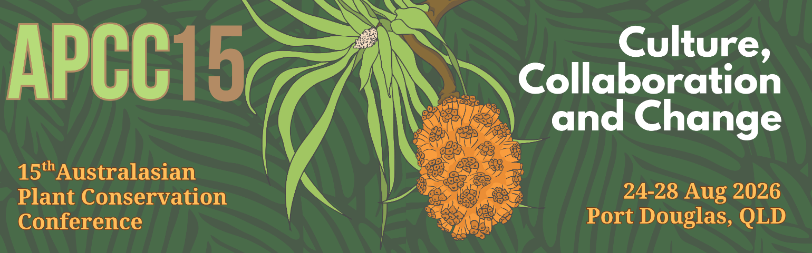

Abstract submission form – due 15 May 2026
Please use this form to submit an abstract for a conference presentation or poster.
To complete the form: type details in the boxes, save, then send by email to
business@anpc.asn.au.

PRESENTER DETAILS

Title First Name Surname
Current Position Organisation

Co-author(s)
PO Box/Street address
Suburb/Town State Postcode
Preferred phone number Email
Presenter’s biography (maximum 40 words)

ABSTRACT SUBMISSION

Presentation (or) Poster
I would like my abstract to be considered for the following plenary theme(s) (please tick):

Sustaining Diversity

Restoring Balance

Collaborations and Culture

Biosecurity, Invasive Threats and Post-invasion Challenges
No theme

For more details on the Plenary Themes please refer to our website
https://www.anpc.asn.au/conferences-apcc15/

Note: Presenters will be allocated 15 minutes in the Conference Program for their presentation. 10 minutes will be allocated for questions to all presenters at the end of each session.

Tick here if you are prepared to submit a full-length paper (approx. 1200 words) for publication in Australasian Plant Conservation (you will be contacted by the editor prior to the conference). The deadline for this is 1 November 2026. Email editor@anpc.asn.au for any queries about submission of full-length papers.
Proposed title of presentation / poster:

Abstract (maximum 250 words):

Note: Please submit abstracts via email to business@anpc.asn.au by Friday 15 May 2026.
Abstracts should be no more than 250 words in length.
All abstracts will be made available online for download by conference participants.

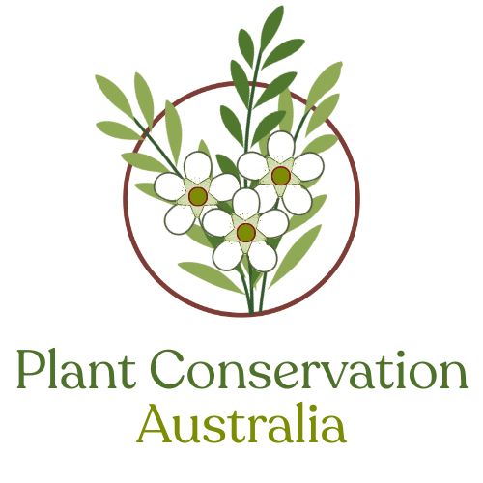

Plant Conservation Australia
GPO Box 1777, Canberra, ACT, 2601, Australia

Telephone: +61 (02) 6250 9509
Email: business@anpc.asn.au
Web: www.anpc.asn.au

